Learn to Program in JavaScript: Beginner to Pro

Introduction to JS

- JS is a lightweight programming language developed by Brendan Eich.

- It was first coined as “LiveScript” but when Netscape partnered with Sun microsystems, they changed it to “JavaScript”.

- ECMA (European Computer Manufacturers Association) standardize JS.

- It makes the websites responsive and usable since it is a programming language.

- JS code containing files can be linked to HTML or the code can be used with in a HTML file using “<script> </script>” tags.

REPL (Read Evaluate Print Loop)

REPL is a style that browser console uses. Basically, it loops - read, evaluate and print functions, so we can simultaneously give inputs and check outputs in the browser console. The below is an example of REPL style console which first reads from the user and evaluates it and prints it as undefined. After the termination process it again prompts the user.

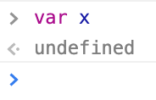

Flavor of JS

- JS is a scripting language in which set of statements is interpreted.

- It supports multi-programming paradigm (Multi-programming paradigm means mixture of different programming language that includes procedural (c), functional (Haskell) and OO programming (C++ & Java))

- JS functional programming treats functions as data so it can be passed as arguments and can also be returned while JS OOP is quite different it is not class based but prototype.

- It’s also a Dynamically Typed language whereas C, C++, Java are Statically Typed.

*Difference between class and prototype: Prototypes vs. Classes. The most important difference between class and prototype-based inheritance is that a class defines a type which can be instantiated at runtime, whereas a prototype is itself an object instance.

*ES6 include class (<https://googlechrome.github.io/samples/classes-es6/>)

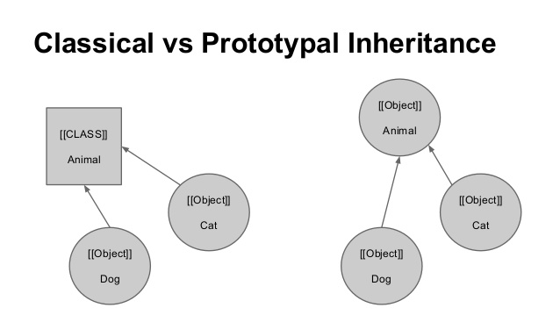

Data Types

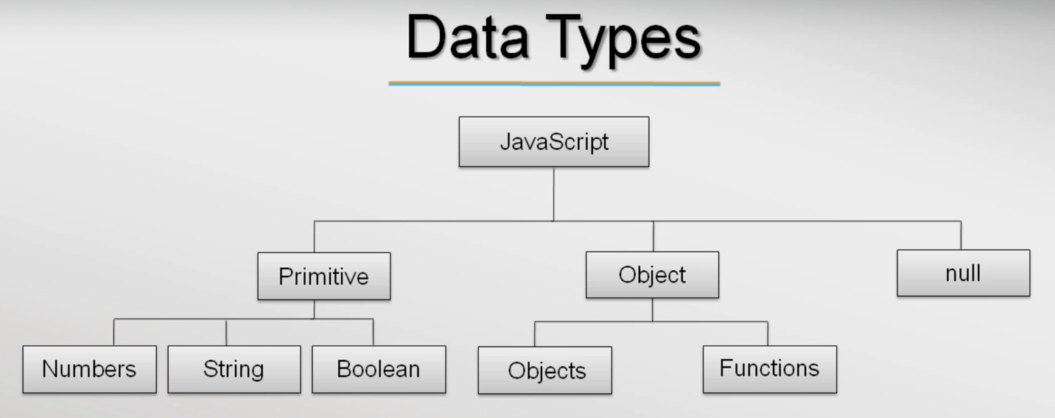

“var” is a keyword used to declare variables. Comparing this variable declaration with other programming languages we can clearly see that the type of variable is not mentioned during declaration that means JS support Dynamically Typed variables. Programming languages like C, C++ and JAVA are Statically Typed. Ex: var messages = “Hello”; - In this statement the browser console interprets dynamically and sets the type of variable when we assign value to it, if no value is given console simply takes undefined.

- JS has categorized its data types into 3 as follows,

— Primitive (Numbers, String, Boolean).

— Object (Apart from primitive types rest were considered objects even functions are considered as objects).

— Null (is a special type of object in JS that represents “no-objects”).

— Undefined is datatype, means a variable has been declared but has not yet been assigned a value

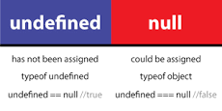

- Below shows the feature of dynamically typed variables,

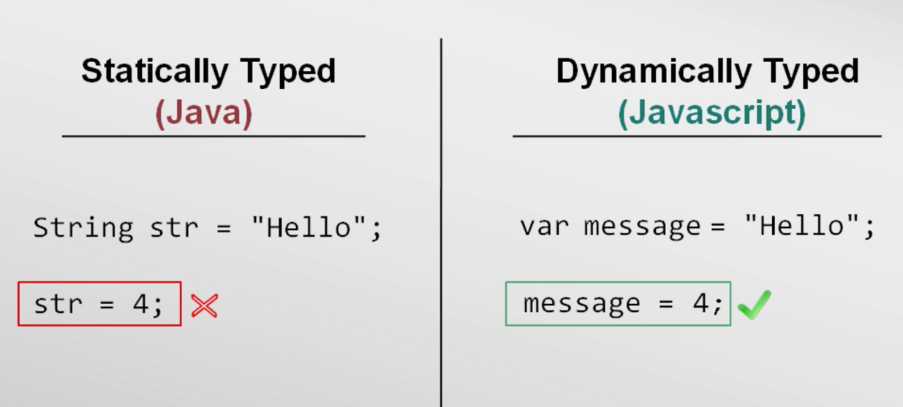

Ex: In the example below the variable msg can be assigned to different data without any warning or error. This is the beauty of Dynamically Typed language.

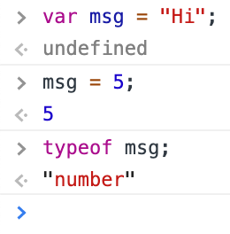

Primitive datatype

- String datatype

A string’s each character is stored as 16 bits of storage and UTF-16 format is implemented by default. We can use either double or single quotes for strings. Ex: var msg “Hello world” or ‘Hello World’ both are fine, where Hello world string is called string literal. JS has no inbuilt character data set, so string constrain is applied. To make use of “” or ‘’ quotes within a literal escape sequences (\) is applied. Different usage of escape sequence in JS is shown below,

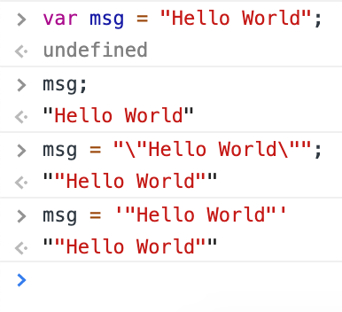

- Number datatype

JS doesn’t support int or float or any other type like other programming language. It’s just var here. Numbers are stored as 64-bit floating-point.

- Boolean datatype

False values in JS are undefined, null, 0, NaN (Not a Number) and “” (Empty string). The below code snippet explains the boolean functionality in JS

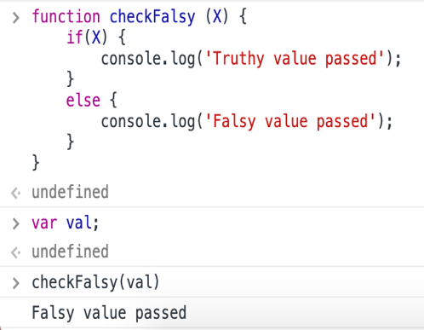

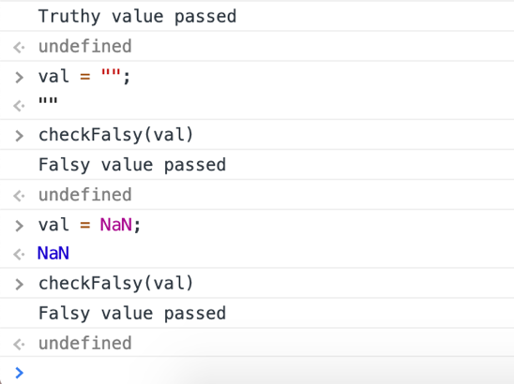

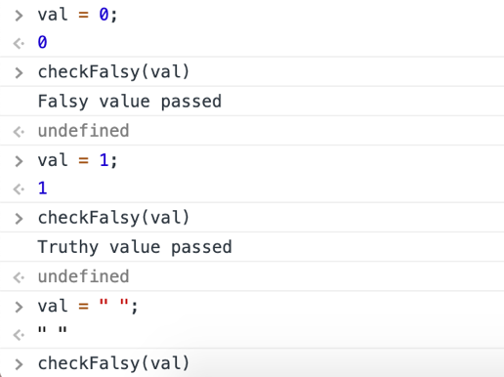

Comments

// 2 forward slashes for single line comment

/* Forward slash followed by a star char as start for multiline comment and these comments should be terminated by a star and a forward slash */

Operators

Basic operators in JS are as follows,

- Mathematical operators: +, -, *, / and %.

- Conditional operators: <, > <= and >=. Ex: “aa” < “ab” 🡪 prints true, since the JS interpreter checks this condition in alphabetic order.

- Equality operator: == and Inequality operator: !=. Ex: “2” == 2 🡪 prints true, the reason is to throw minimum errors during runtime thought they are different types. To check the type as well as the value === equality operator should be used, “2” === 2 🡪 prints false.

- String operators: typeof and instanceof.

Statement and Expressions

“var x = 5;” is a statement and is evaluated as undefined in a browser console because it is not returning any value, so it is undefined. While “x = 5;” is an expression but is evaluated as 5 that is console prints 5 since we assign the variable to a value.

// a statement that has no value

int x = 5;

// an expression...

x = 10;

// expression can be passed around

printf("%d\n", x = 15);

// (<https://stackoverflow.com/questions/3880093/var-variable-returns-undefined>)

Control flow statements (if-else, nested if-else, switch, while and do-while)

- “if” works with range of values.

- “switch” works with discrete values.

- “while” executes code block when the expression is true.

- “for” is a sugar-coated syntax of while.

- “break” and “continue” are keywords which we can use inside a looping statement. Just for our convenience.

Ex: break statement

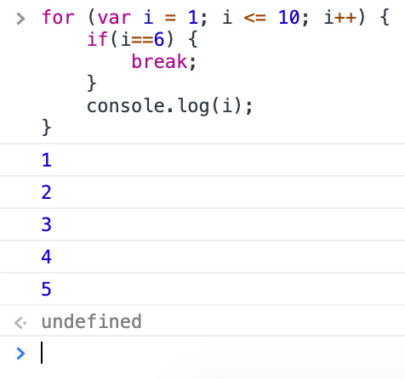

Ex: continue statement

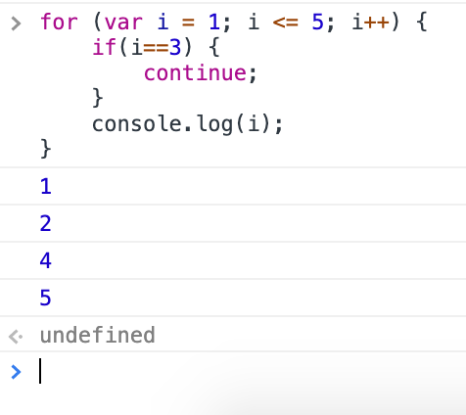

*It’s better to use if than switch because switch consecutively executes the cases after the desired expression. So that’s why break; statement is put below each cases.

*JS also supports multiple version of for loop one such version is for-in loop and its syntax 🡺 for (var x = I in book) { ... } // where book is an object or an array

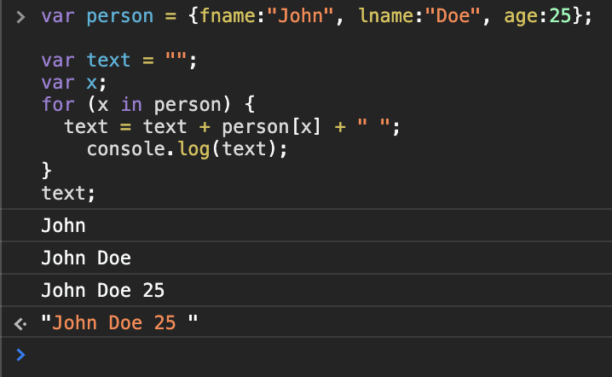

Functions

- Since JS is a multi-programming paradigm, so it supports functional programming. Hence JS treats functions as first class citizens.

- Functions are treated as data or objects so they can be passed as arguments as well as a functions can also return a function. Ex: Callback function in filter, map and reduce functions are passed as arguments

- “function” is a keyword declares a function followed by its name.

- Function parameters don’t have type information same as var.

- Functions basically returns something, even JS function returns same as C++ or Java. But in C++ or Java when a function has nothing to return it returns void whereas JS returns undefined.

Ex: Function returns

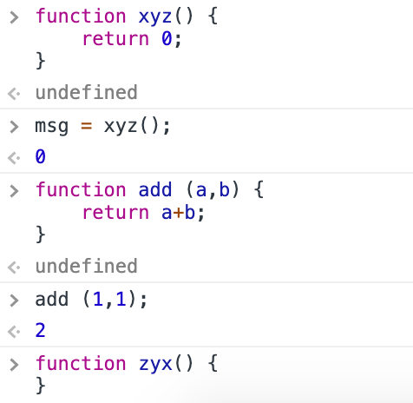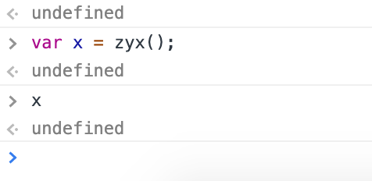

Block Scope & Function Scope

Block scope - A variable declared with in the curly braces, it could be in a function or in a control flow statement then that variable can only be accessed with in the curly braces.

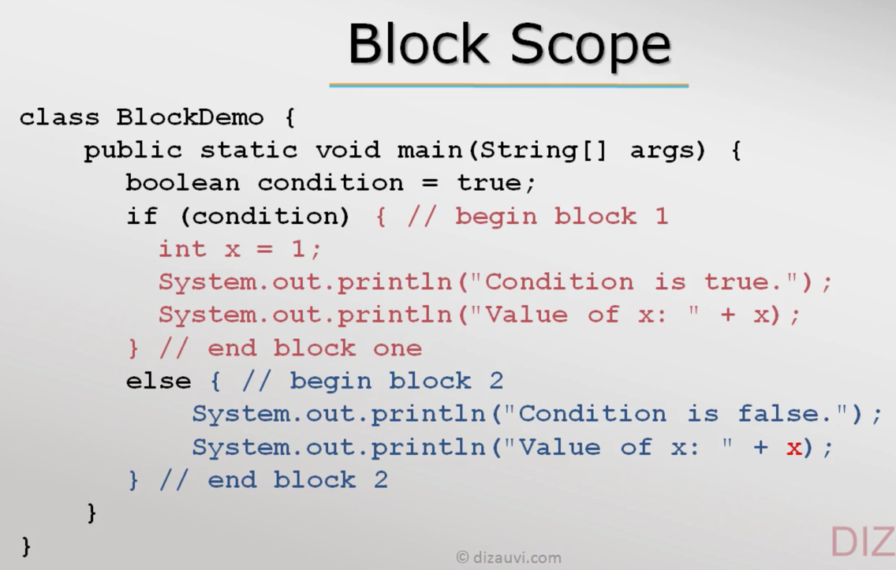

Function scope - A variable declared with in the function cannot be accessed outside.

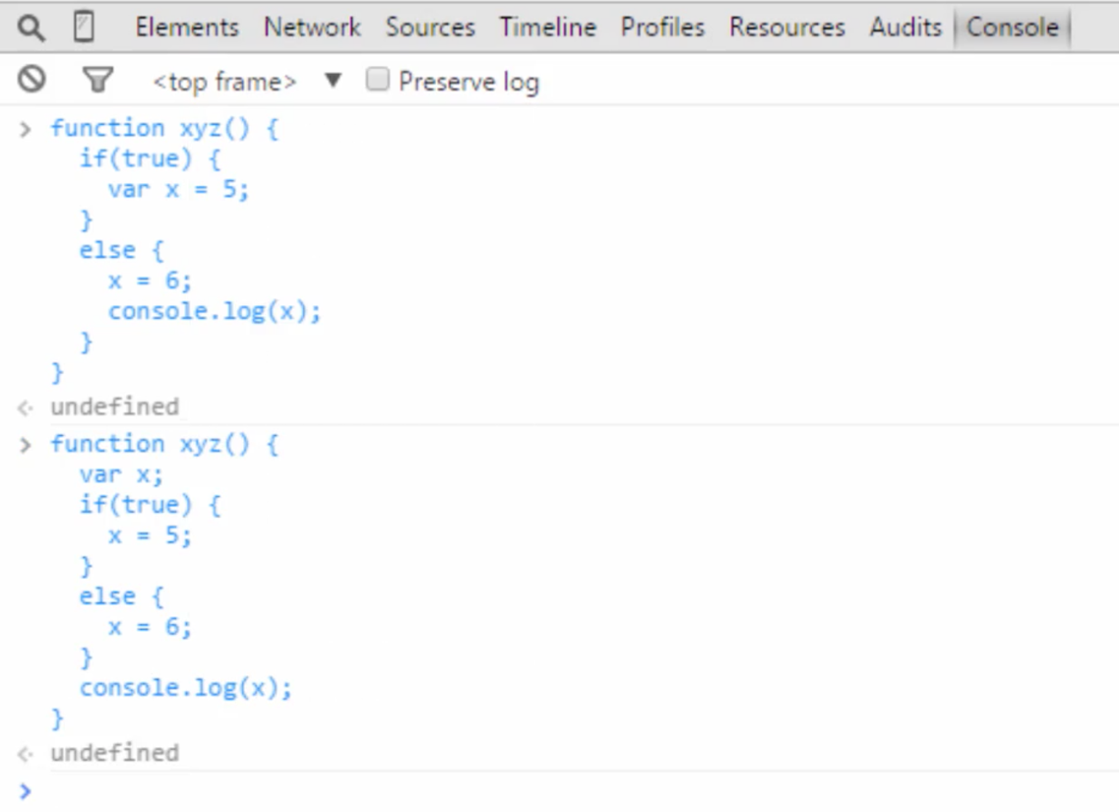

Type Conversion

Like other programming languages JS also supports type conversion but here it does some additional functions to avoid errors at run time.

Ex: Below the * and + are treated differently. Though “2” & “3” are strings they are considered numbers when we use * but when we use + the interpreter appends because + is defined to do the appending operation.

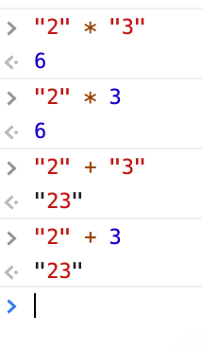

*The basic difference between type conversion and type casting is that the type conversion is made “automatically” by compiler whereas, type casting is to be “explicitly done” by the programmers. The two terms “type casting” and “type conversion” occur when there is a need to convert one data type to another.

*Also, operators do more function apart from their normal nature. like the + operator can add two numbers and also it appends two strings.

JS in a web page

Always put JS codes in a single place instead of using script tags throughout the HTML. It can be done in that way, but it is a bad practise. The below html code has lots of script tags its still valid but it’s better to put JS codes in a single file and link them.

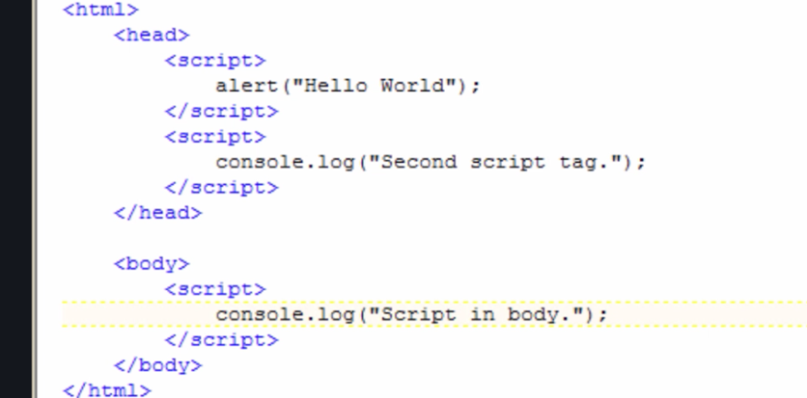

The above picture also shows that the browser will start to execute from head to tail since the html file has multiple script tags. So, the first script tag is executed later the other.

Benefits of external JS (Linking JS files to a HTML)

- External libraries like jQuery, angular JS etc. can be used

- Code can be better organized and reused.

- Intellectual property (not readily available to anyone).

- Cached by browser (Browsers download JS file from servers and stores them in client system)

*Use relative paths in “src” attribute of html “<script> or <link>”tag to avoid directory issues.

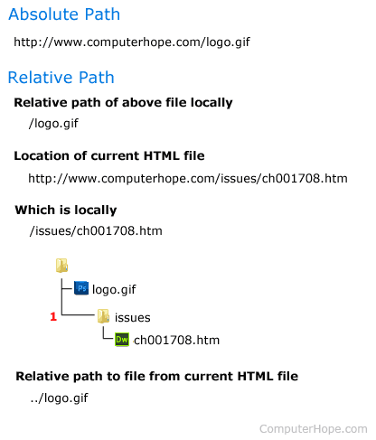

*Don’t use the http or https literals in “src” since there might arise a problem when the html code communicates with the source. If in case the link is supported by http convention but the source as https literal, then warnings or errors may populate. So, it’s better put links like below,



*Its better to follow below convention to avoid errors.

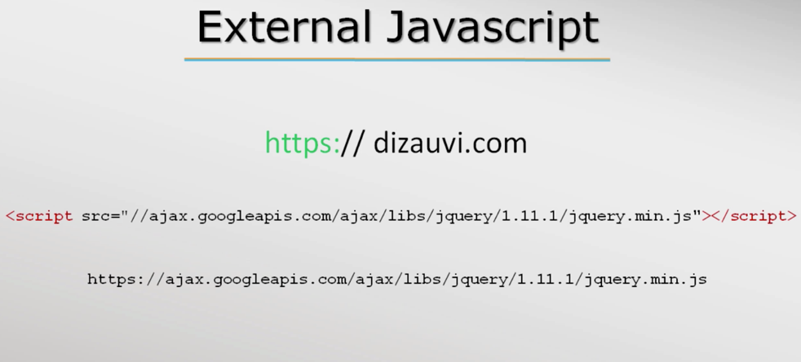

Objects & Array

Objects

Objects in JavaScript may be defined as an unordered collection of related data, of primitive or reference types (array, objects & function), in the form of “key: value” pairs. These keys can be variables or functions and are called properties and methods, respectively, in the context of an object

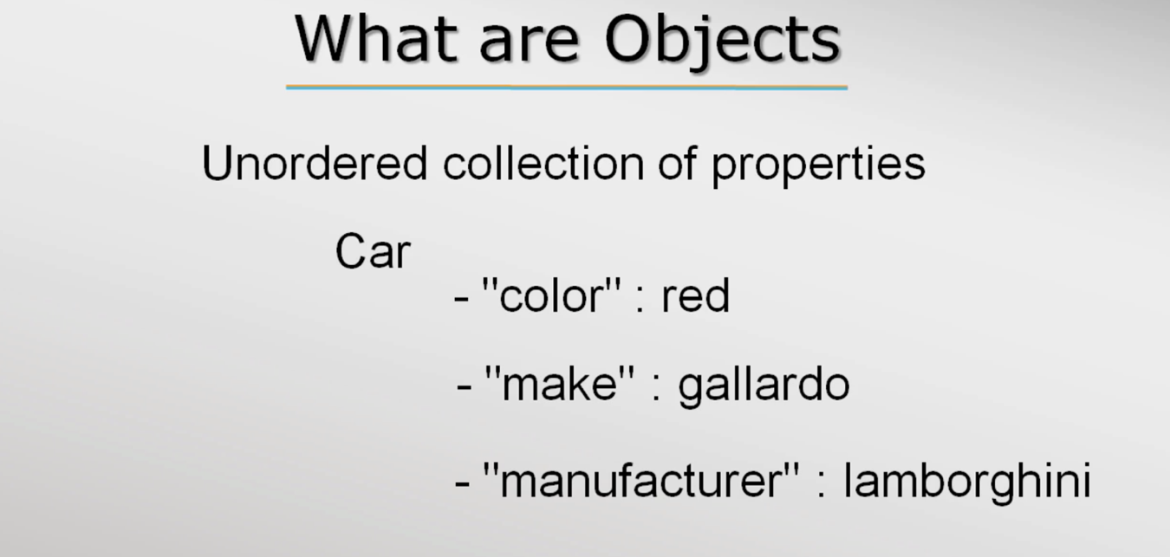

*Reference types: A reference type can contain other values. Since the contents of a reference type cannot fit in the fixed amount of memory available for a variable, the in-memory value of a reference type is the reference itself (a memory address). (<https://gist.github.com/branneman/7fb06d8a74d7e6d4cbcf75c50fec599c>)

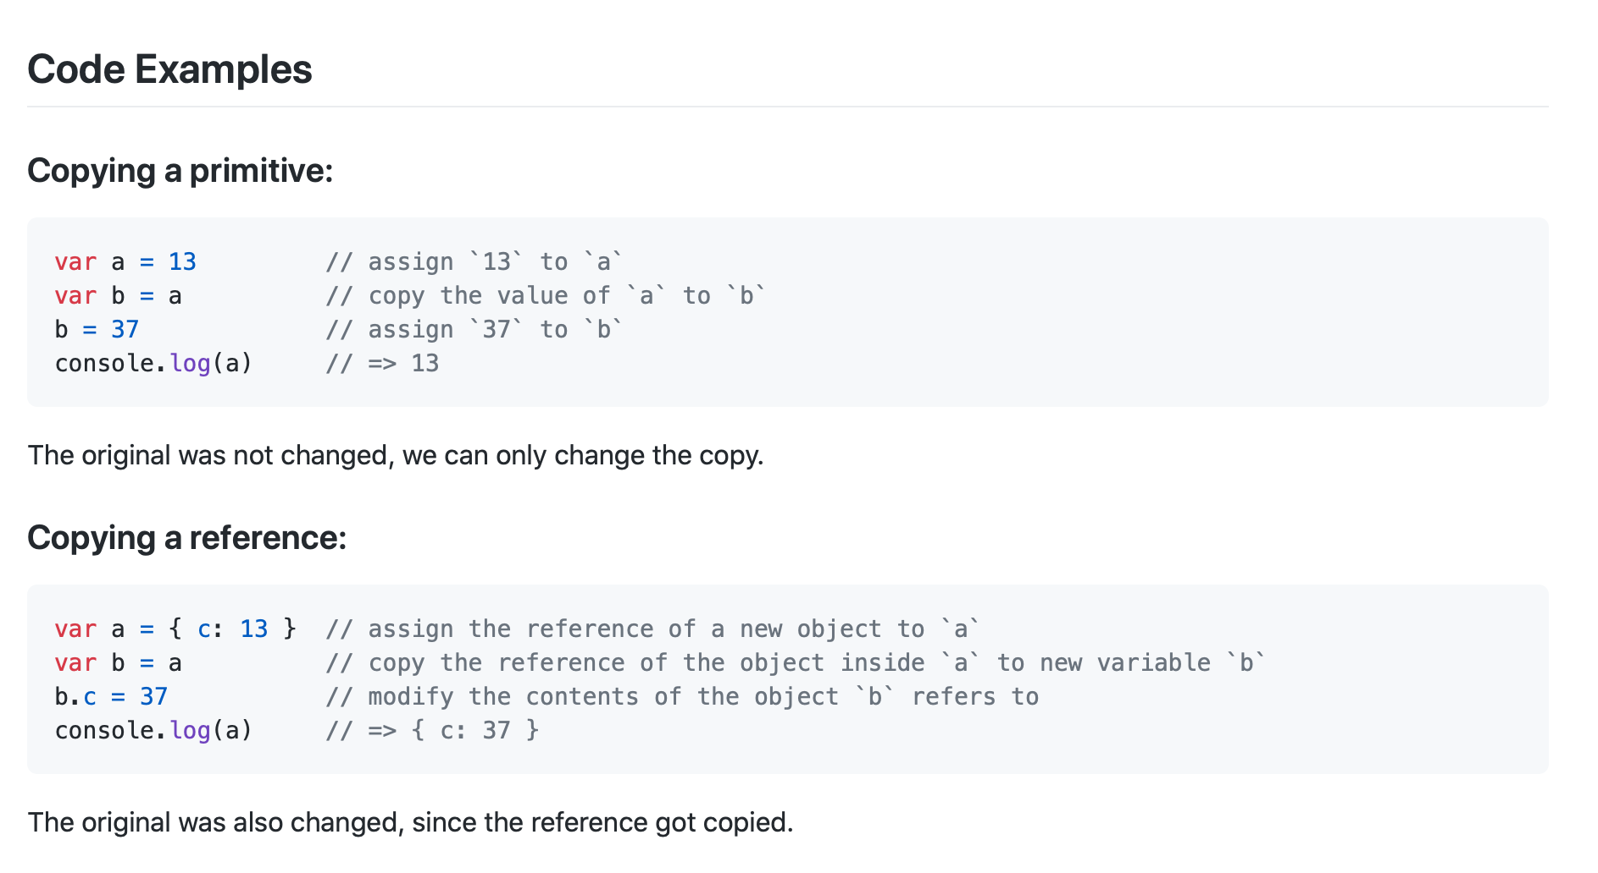

- Car is the object and that has the above properties.

- “color” 🡪 property name and they must be a string but it is not necessary to put them in double quotes.

- red is a value for the property “color”.

Ex: Object usage in JS.

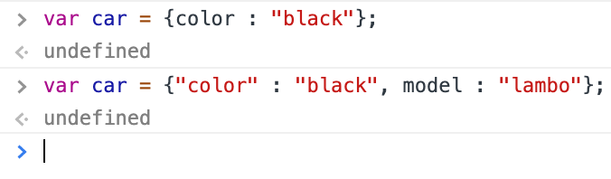

*Same kind of object structure is followed by Python.

Ex: Initializing empty objects with no properties.

>var car = {}; // car is an object initialized with no properties

<undefined

>car;

<Object {} // var car belongs to object data type

Ex: Initializing objects with new keyword without properties and later properties are added using dot (.) operator.

>var car = new Object(); // var car is initialized with new object

<undefined

>car;// car is empty object

<Object {}

>car.color = “black”; // adding properties to the object

<“red”

>car;

<car = {color : “black”}

Ex: Initializing empty object using the method create().

> var car = Object.create(null); // create takes argument so pass null to create an empty object

<undefined

>car;

<{}

- JS is a prototype-based OOP language, not a class based, so objects itself an instance and instances can be created for the object.

*Difference between instantiation and initialization: Instantiation refers to the allocation of memory to create an instance of a class whereas initialization refers to naming that instance by assigning the variable name to that instance.

Object properties

- Properties of objects can be accessed using (.) dot operator as well as the using associative array.

Ex: Accessing Object using associative array method.

>var book = new Object();

<undefined

> book[“title”] = “Cracking coding interview”; // write

< “Cracking coding interview”

>console.log(book[“title”]); // read

- Deleting a property is pretty simple just access the property and use the keywork delete.

Ex: Deleting an property.

>delete book.title; // deletes the property title

<true

>book;

<{} // empty object

- To iterate over object properties in JS, for/in loop is used.

Syntax: for/in loop

for (var x in book)

{

// code block

}

Ex: for/in loop

>var book = Object.create(null);

<undefined

>book;

<{}

>book.title = “Cracking the coding interview”;

<“Cracking the coding interview”

>book.author = “Gayle Laakmann Mcdowell”;

<“Gayle Laakmann Mcdowell”

>book;

<{ title: “Cracking the coding interview”, author: “Gayle Laakmann Mcdowell” }

>for (var print in book) { Console.log(print + “ - ” + book[print]); }

title – Cracking the coding interview

author - Gayle Laakmann Mcdowell

> |

- Normal empty object has additional properties which comes from object prototype.

Ex: Console shows inbuilt properties of the object Animal.

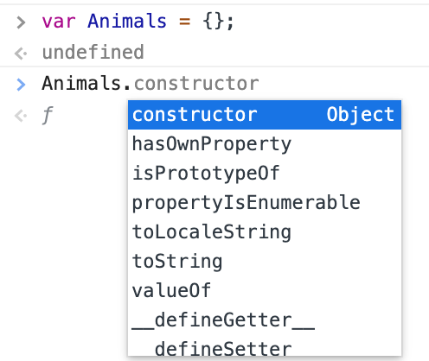

---------------------------------------------------------------------------------------------------------------------

JSON – Java Script Object Notation

- JSON is a very popular data format that represents data as strings and it is sent between client and server.

- JSON data format is more readable so it is primitively used over its competitor XML.

- JSON data is represented similar to Objects representation in JS but both are different. Where Objects accepts ‘’ while JSON doesn’t accept single quotes ‘’.

*JSONLint is an open source project which allows you to validate your JSON data. Since when you are working with any programming language and JSON, if your JSON data is not properly formatted, it can cause error, it is better to validate your JSON data beforehand.

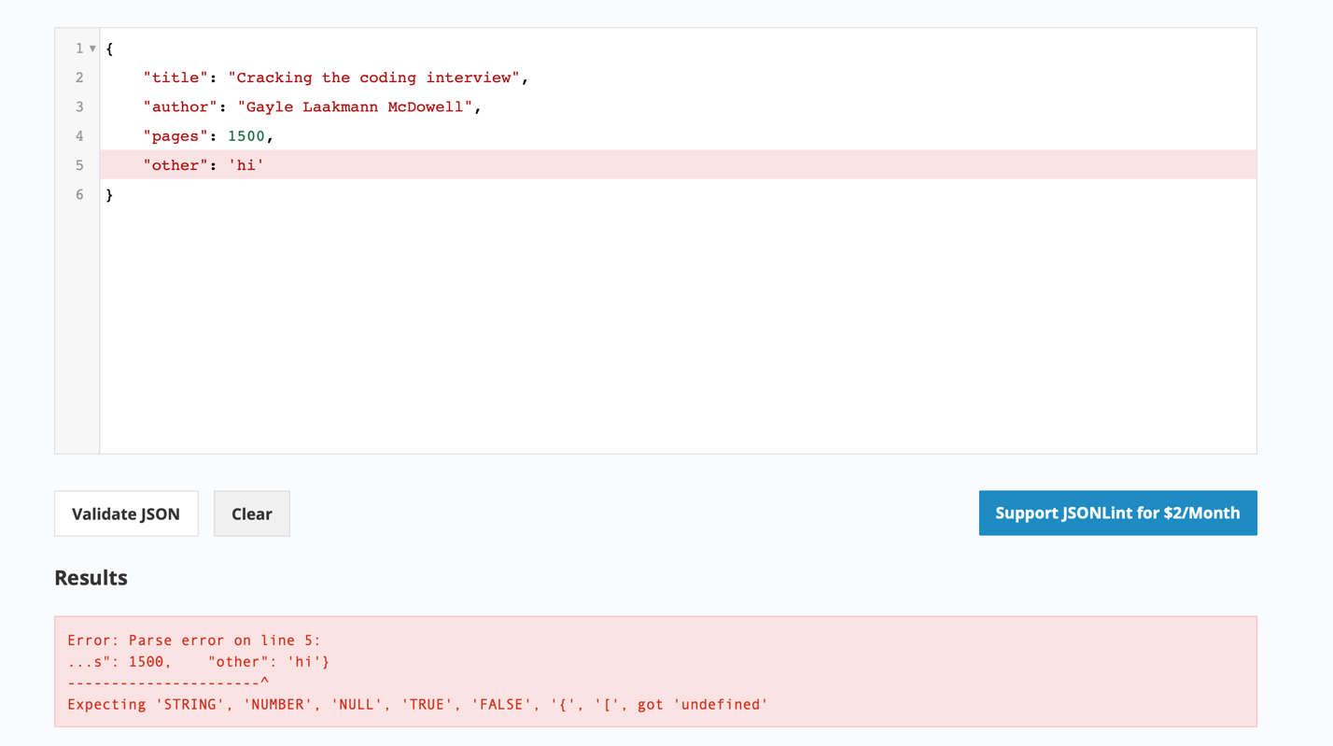

Converting var book_as_string – string literals which is in JSON format to Objects using JSON.pasre() method

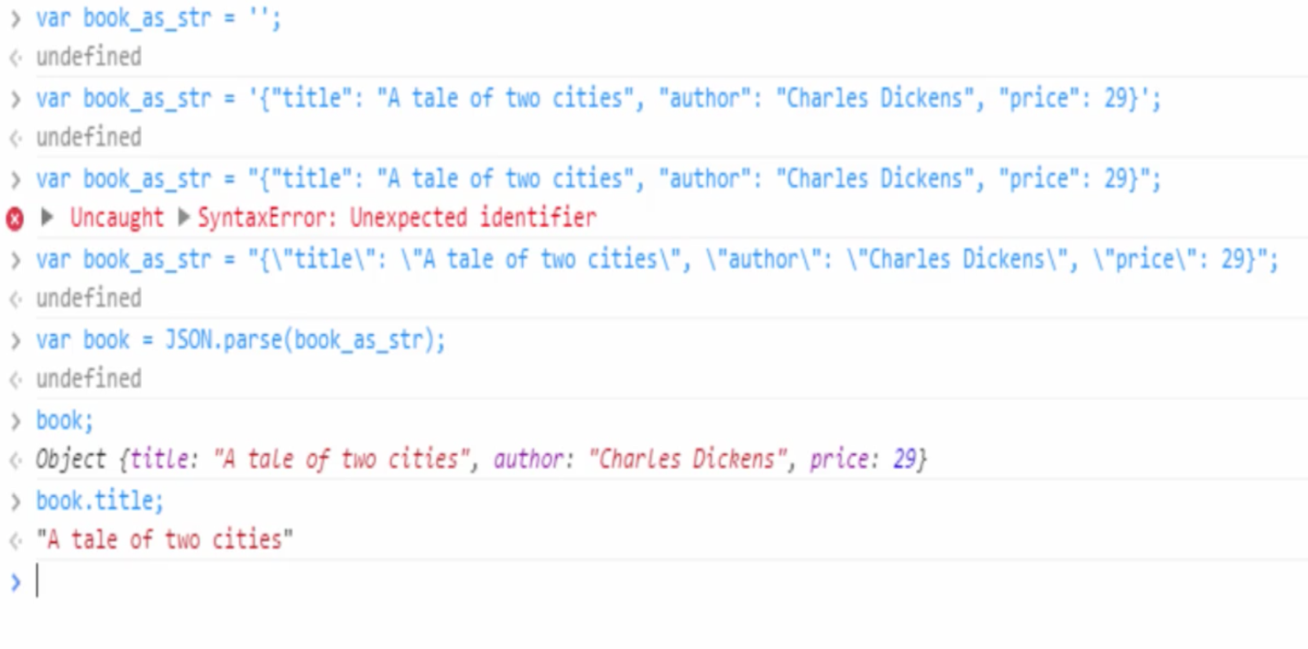

*

- XML are really a big deal to parse data in JS. And this is why exactly JSON’s are prominent.

- JS objects can also be converted to JSON

* The default conversion from an object to string is "[object Object]"

- What is the output of the following code snippet?

>({title : "The Three Musketeers", author: "Alexandre Dumas", price: "$49"}).toString()

<[object Object]

Global Object

- Like other programming languages JS also links functions but it happens quite different here.

- JS has no linker but has globalThis object, which ties everything together.

- In the browser environment globalThis is the window object, so when the new pages load up JS interpreter starts and creates a new window and put all properties.

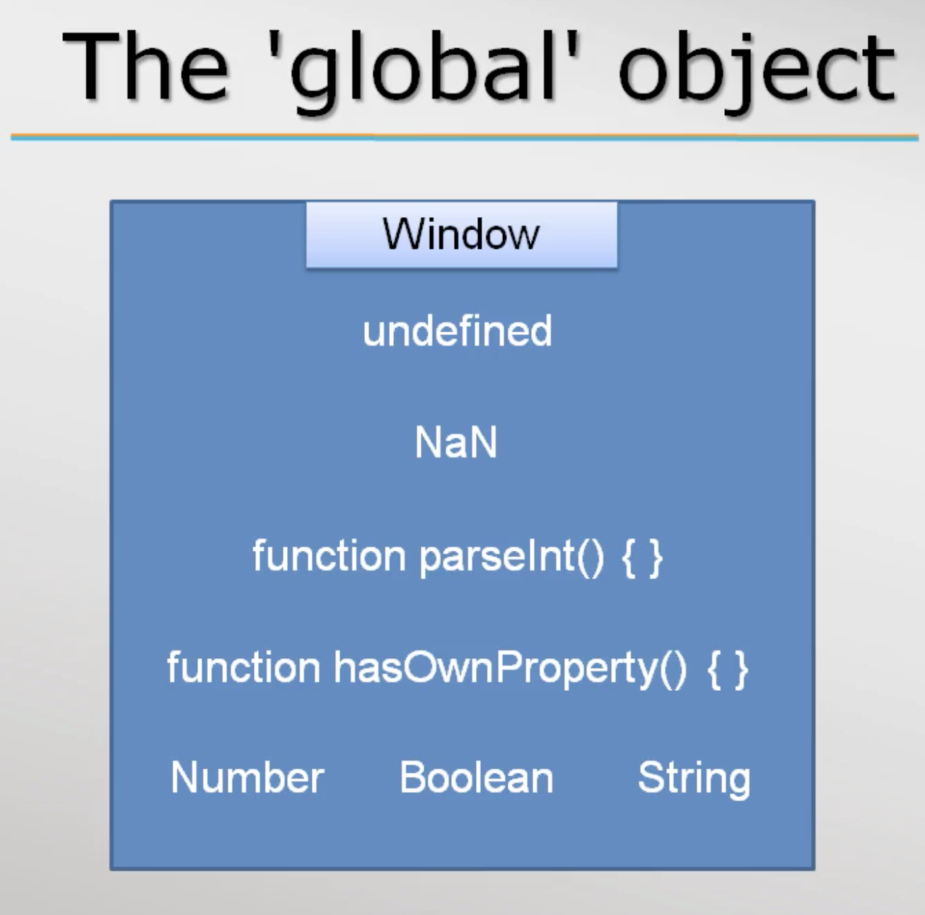

- JS interpreter always has a globalThis object but in case of a browser globalThis is called Window.

Both are same 🡪

>global === window

<true

- the variable, functions and objects which is created will become part of Window object.

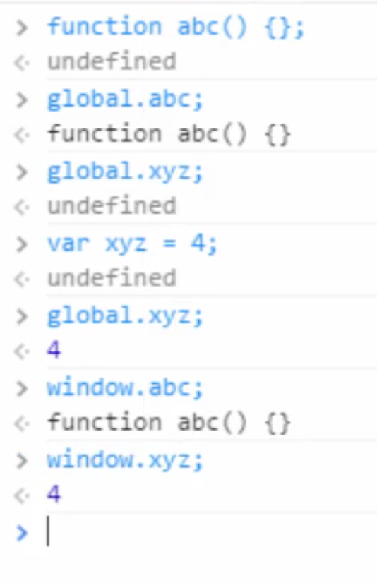

Arrays in JS

General definition of an array: Array is basically a data structure or container object that holds a fixed number of items of specific types. Memory layout of an array is contiguous

But in JS Arrays don’t follow their general nature.

- They can be initialized with zero element.

- items can be added to the array later. That is it grows dynamically.

- obviously they don’t have a data type. Hence we can store any type of element.

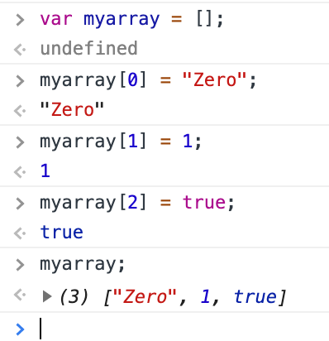

Sparse(scattered) Array

In JS we can load values to any index without error and warnings.

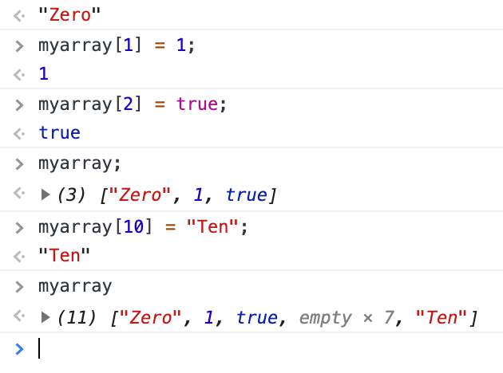

In other programming languages array elements should be adjacent to each other. But JS overrules the traditional rule.

Array as objects

- The reason why arrays are so convenient in JS is because they don’t have any underlying data structure. They use objects has their data structure.

- Arrays work like this🡪 Array indices are converted to strings and these strings will hold values. Exactly like properties in object, where properties are strings. can hold. Hence JS just makes up array but in fundamentally it is an object.

The below code snippet shows array as objects,

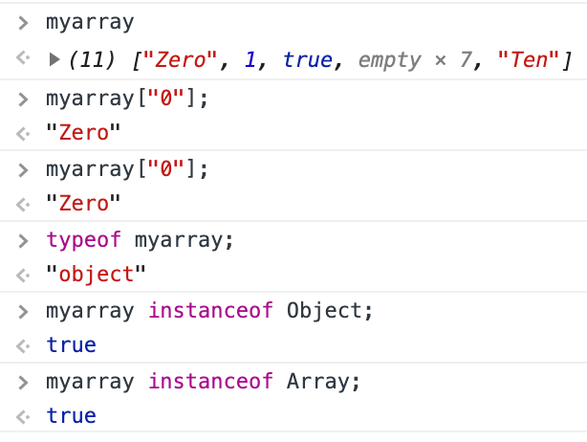

Array is a function but remember a function can also be an Object in JS.

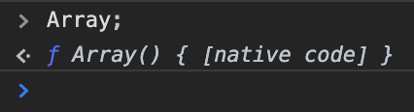

Here the myarray takes a string as indices but still add the values to it.

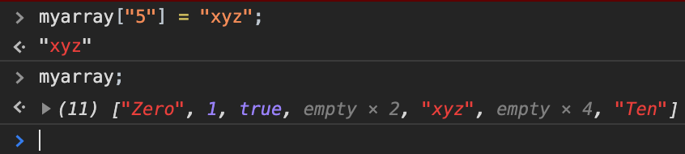

Length of an array

- As previously mentioned, array is an object in JS. So it has predefined properties. Length is one such property of array object. Length property can be accessed as show below,

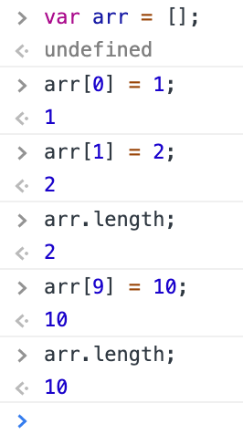

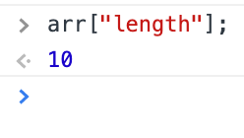

- Since length is a property, we can also use the index notation to print length of the array.

- When iterating an array of 10 elements it shows undefined for 7 which in between the index of 2 and 8. Because as in the previous screenshot it is shown that only 3 indices [0,1 & 9] of array were assigned rest were left empty. So the console throws undefined for the 7 elements and pints the value for rest.

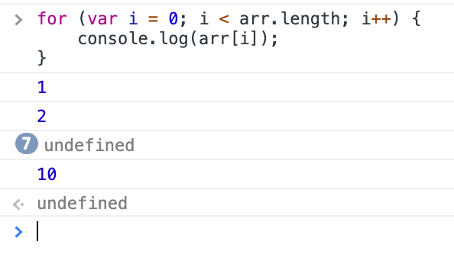

- Since length is a property, we can also set value to it. Like shown below, if we set less value to length property though it’s length is beyond the assigning value. It will still accept the value and will truncates.

The length property can be dynamically change when we assign new value to different indices.

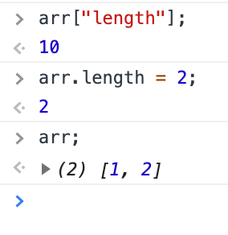

Iterating over an array

For loop can be used to iterate over an array. What if we want to iterate only the valid elements. In the screenshot below for loop iterates all elements including the undefined, which are not assigned.



The below condition can be used to avoid undefined,

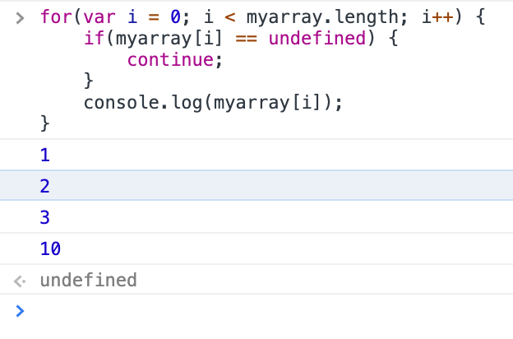

Or we can also use for/in loop, that access each property of an object. For/in loop leaves out undefined property.

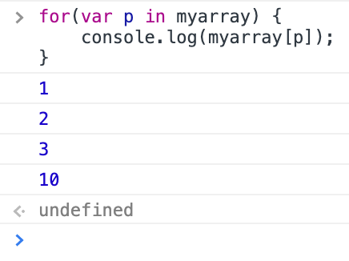

- but for/in loop is not recommended to use because JS may add property to array object and it might print. So the best way is to use “hasOwnProperty” property like below,

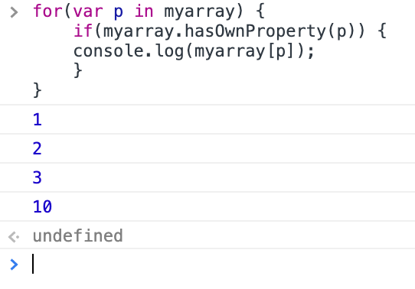

Deleting elements of an array

- Simply use delete key word and mention the index of the element to delete. Array length will not be affected, JS just assigns the deleted element to undefined.

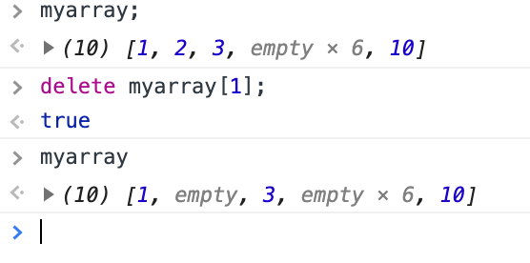

- if we want to shrink the length of the array element when deleting an element, splice method should be used

Methods in an array

- concat

- join

- push and pop

- splice

- slice

- sort are some basic methods in array object.

- concat(): used to join 2 or more array into one.

Ex:

>var a = [1,2,3];

<undefined

> var b = [4,5,6];

<undefined

>var c = a.contact(b); //concat method takes array as argument

<undefined

>c;

<(6) [1,2,3,4,5,6]

>var d = a.concat(b,c);

<undefined

>d;

<(12) [1,2,3,4,5,6,1,2,3,4,5,6]

- join(): gives the string representation of an array with a separator. The default separator is “,” but we can give any thing we want.

Ex:

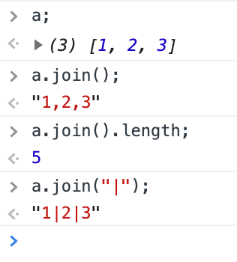

- push(): add new element at the end of the array and returns length of the array. Similar to push unshift() is a method that add elements at the start of the array.

Ex:

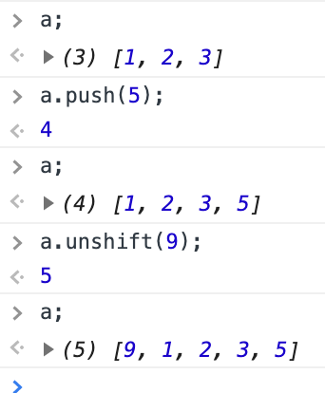

- pop(): is used to remove the last item and returns the element of removed. Shift() is used to remove the first element of the array and returns the item removed.

Ex:

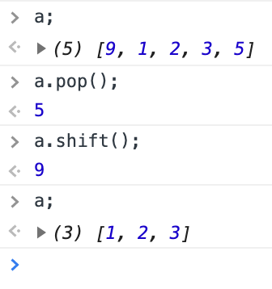

- slice(): slice returns a new array object without affecting the old array. And it takes at most of 2 arguments, the first one is the start index and second one is the end index.

Ex:

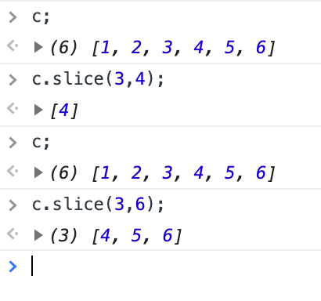

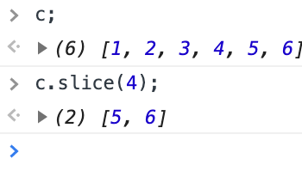

- splice(): splice returns a new array object of spliced element from the old array and also splices up the old array. It take 2 arguments like slice. The first arguments denotes where the index starts while the second shows the number of elements to be removed after the start index.

Ex:

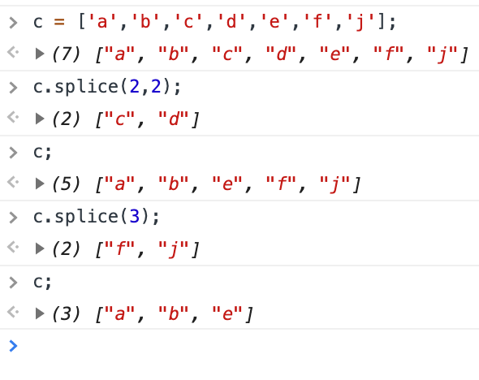

After the 2nd argument it can still take arguments, but they are used to replace the element of old array.

Ex:

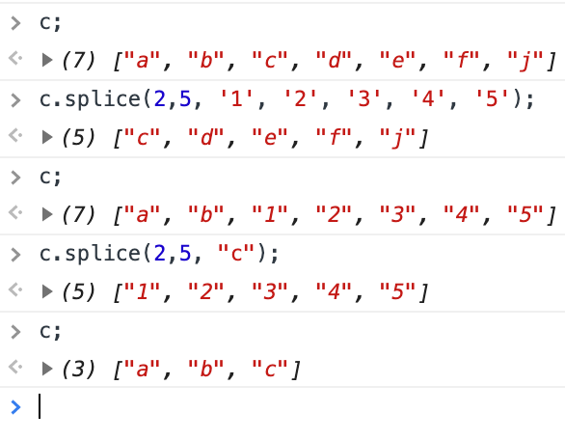

- sort(): will sort the array in ascending alphabet order or lexica graphical or dictionary order.

Ex: this is how the array sorts,

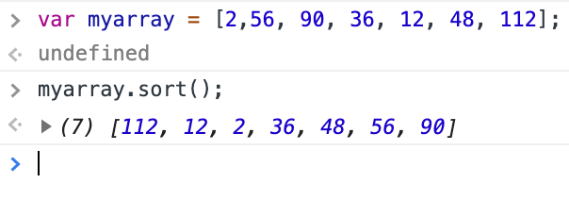

To sort array properly we should use a function and the below is the algorithm of the function should work

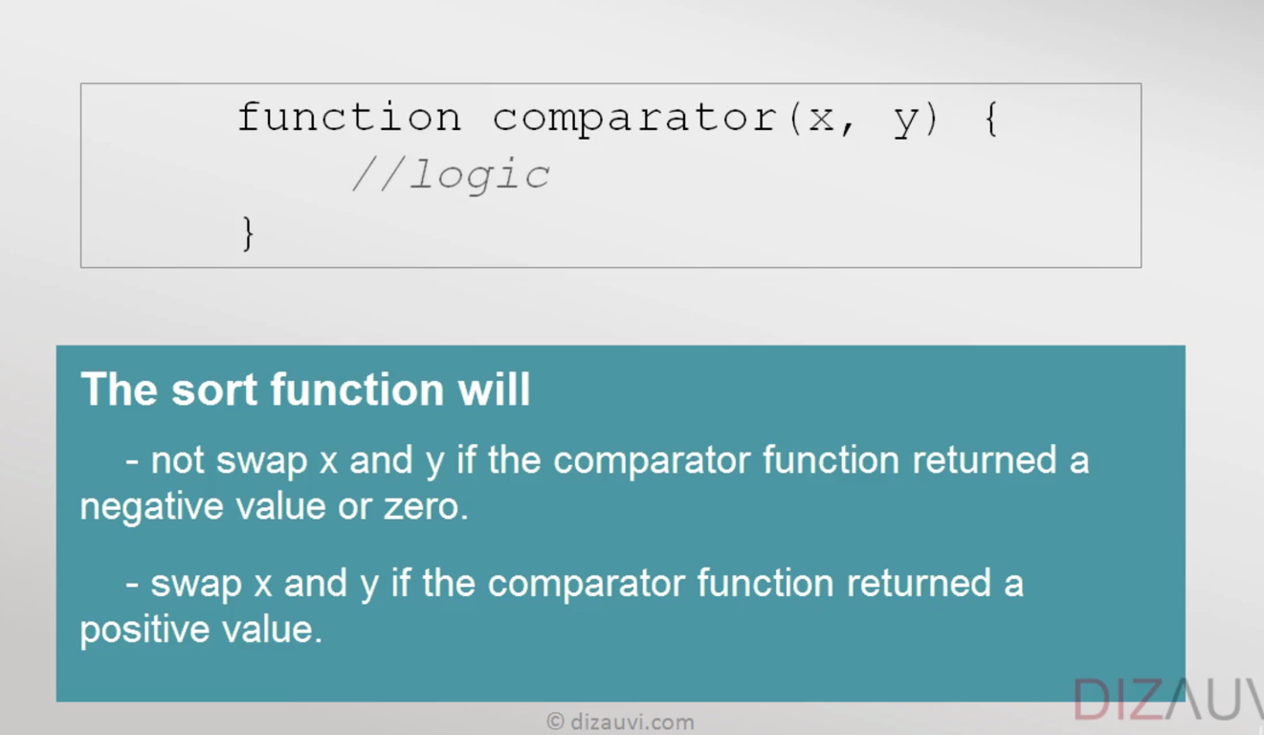

function num_comparator (a,b) {

return (a-b);

}

*no use of parenthesis if a function is not invoked

Ex: the below sorting happened in ascending order

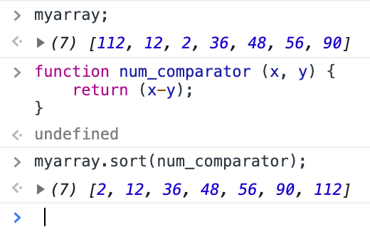

Ex if the sorting to be happened in descending order, just return b-a.

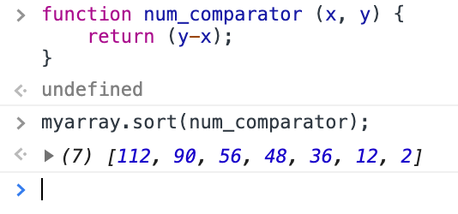

So the sort function only check +,- or 0 of the number returns from the function num_comparator(). And depends on that it sorts.

*idea of passing function as arguments comes under functional programming

Functional programming

Programming Paradigms(patterns)

- Procedural - c

- Object oriented – c++ & java

- Functional - Haskell

And Hybrid (a mixture of above) - JS

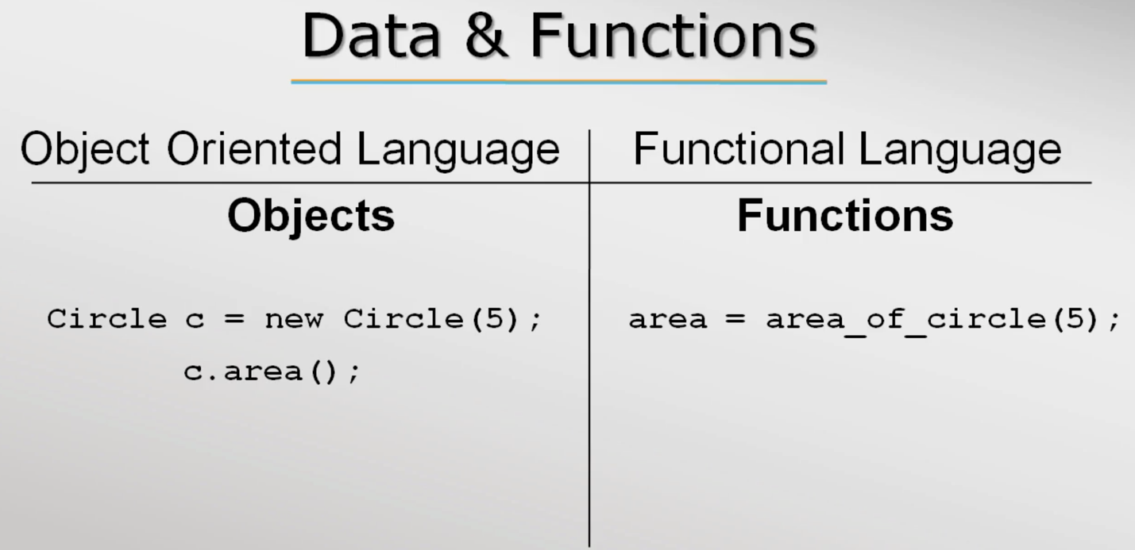

*In the above screenshot the object is created by for the class circle by calling a constructor of the class. This is followed in Java. Whereas, in C++ just object is created without the constructor call. it is implicitly called when the compiler finds the object of the class.

*people always think procedural and functional are same, but they aren’t. In procedural language we can’t store a function in a variable but in functional language we can do that. Since in functional language there is no difference between function and data. Functions are just like objects. 🡺 In JavaScript, functions are first-class objects, because they can have properties and methods just like any other object. What distinguishes them from other objects is that functions can be called. In brief, they are Function objects

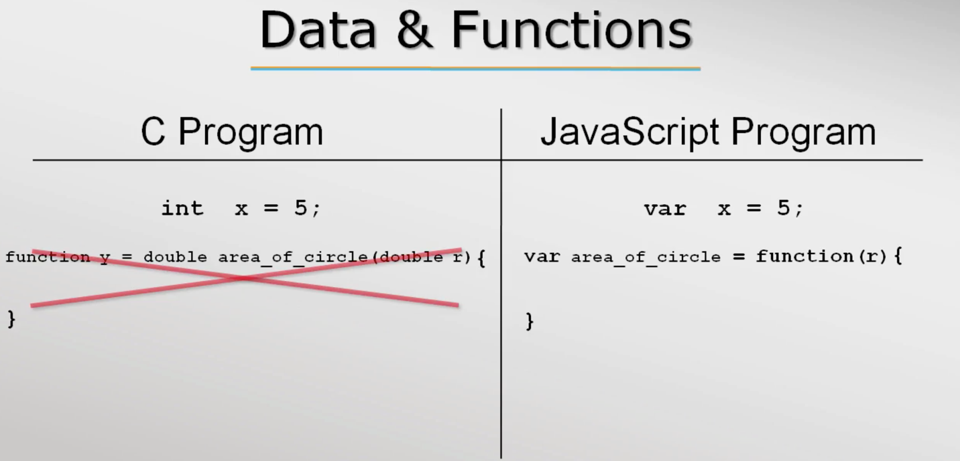

In the example below, you can see that JS treats abc as a variable we can append a value to it and JS takes it as string. But we can also use it as a function and at this time when I append a value it adds.

The forms, function abc() { return 5; } 🡸🡺 var abc = function () { return 5; }

That’s why when I append a value to abc it includes it and gives a string. But if I use the abc as function it will return 5 and appended to the given value. abc() + 6 🡺 11

*So to remember data and function are pretty much treated same

Haskell – data is said to be zero order function and functions are said to be higher order functions 🡪 both are passed as arguments

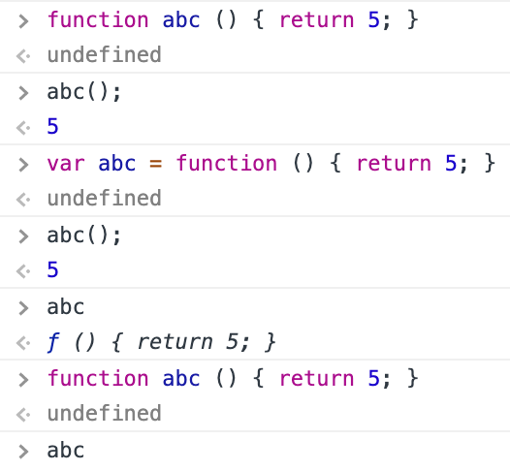

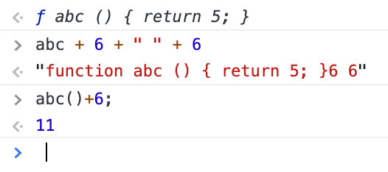

In the above var abc = function () { return 5; } is a anonymous function declaration.

Higher order functions

– functions are passed as arguments since in functional programming functions are considered data

- definition “A function that either takes a function(s) as arguments or return a function” 🡨

🡪 h(x) = f((g(x))

Understanding functions as argument by num_printer example.

- lets create a function that prints 1 to max numbers “num_printer(upto)” typically we will pass a number “upto’as argument to the function print_num(upto) which will print a list of number like this, num_printer(10) 🡪 1 2 3 4 5 6 7 8 9 10.

- what if I need to print odd or even number. mostly what programmers do is write another function which prints odd and even. It’s worth to write another function. In reality it consumes time and effort. So it better to abstract out the changes and pass as argument to the existing function, in this case “num_printer(upto)”, and tell this function to perform required task like print even, print odd or print prime. So this is where functional programming comes to play.

- for the example function we can pass a filter function which will odd out the number.

Ex: function prints max number and takes “upto” as parameter, which will pass number as argument.

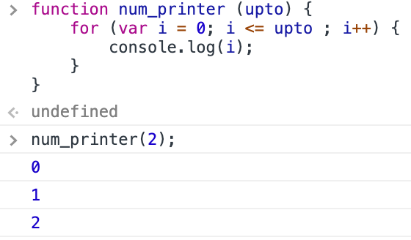

Ex: adding an parameter “filter” to the existing function, where we will pass a function as argument.

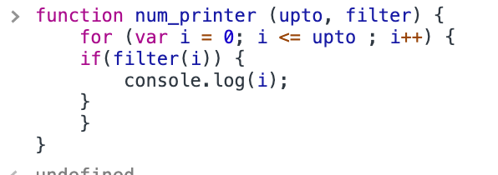

Ex: a separate function that check odd or not and returns boolean is created

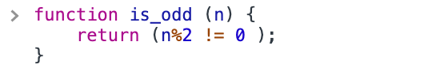

Ex: this is_odd function is passed as argument

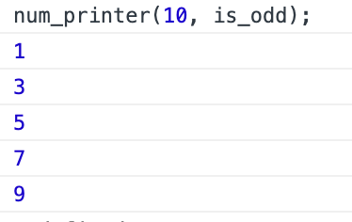

Ex: if I need to print even number means I have to pass another function “is_even” as argument that will return true to the num printer in turn It prints even numbers or if I need to print all number I have to make the if condition true so I need to create a function that returns true.

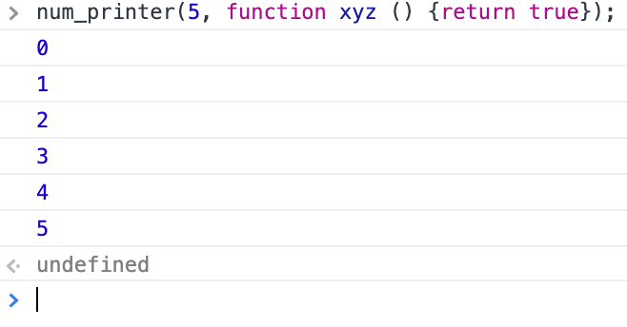

Anonymous function

- Function is JS can be written without function names and they are called anonymous functions

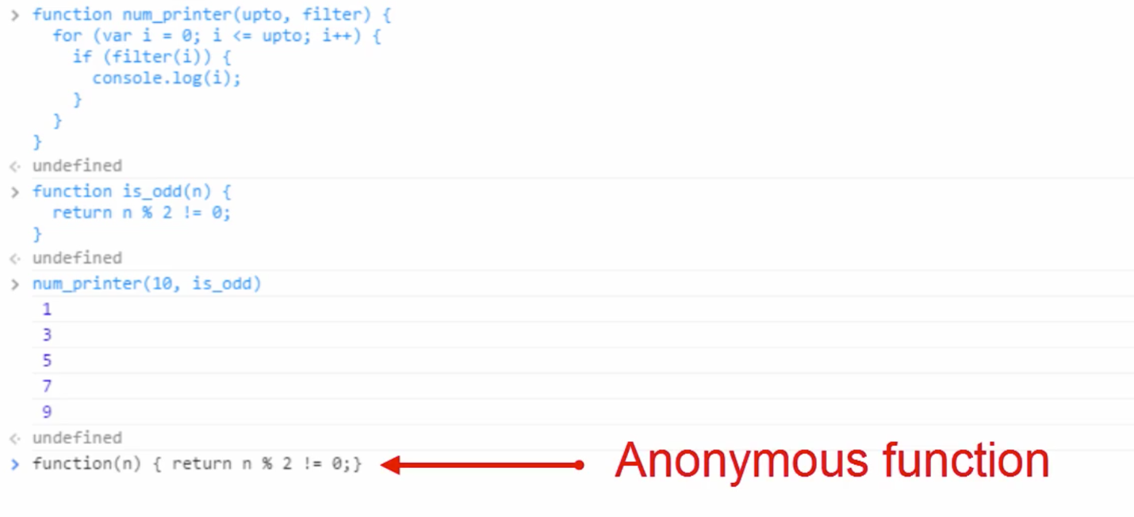

- if we are not giving a name for such function we can’t use it late.

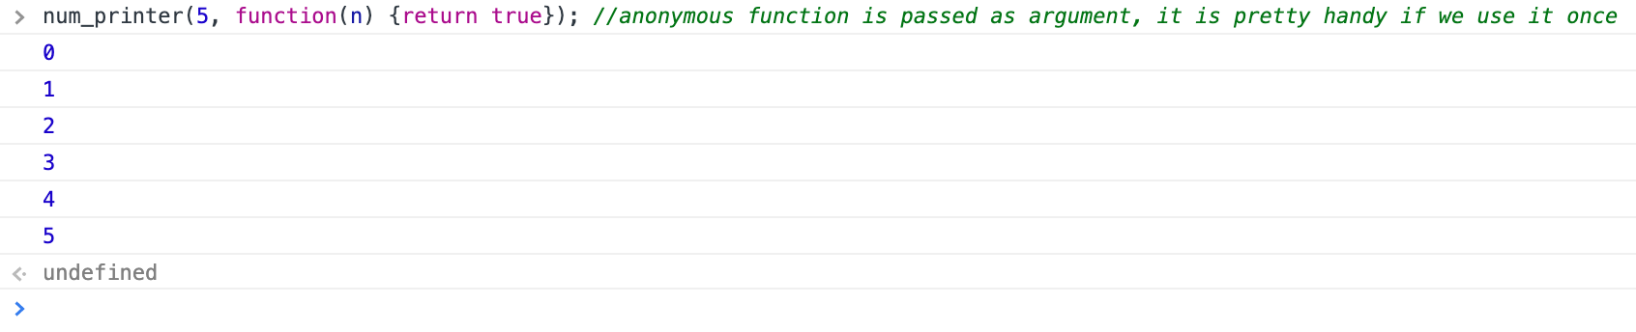

*forEach() is a function that works with array. And it takes function as argument.

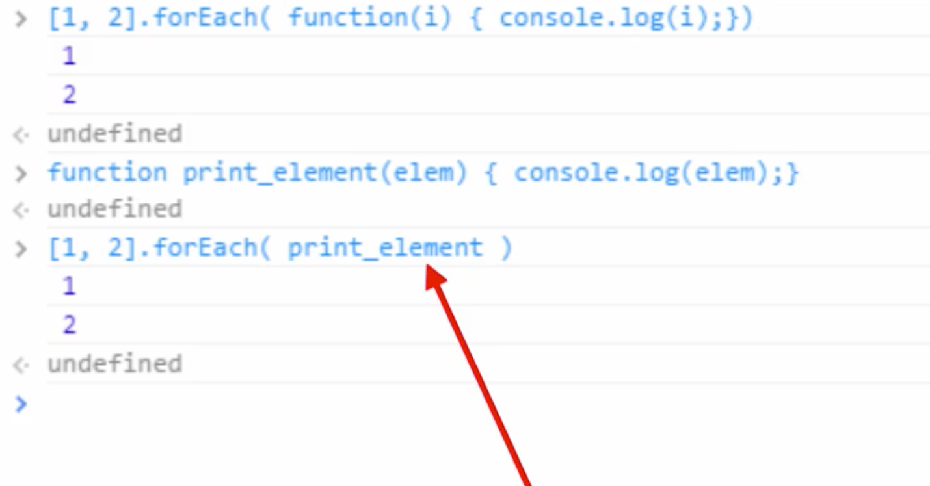

For each function goes to each element of the array and passes the element to this argument, which in turn logged the element.

Nested functions

- function inside another function

- nested function follows functional scope

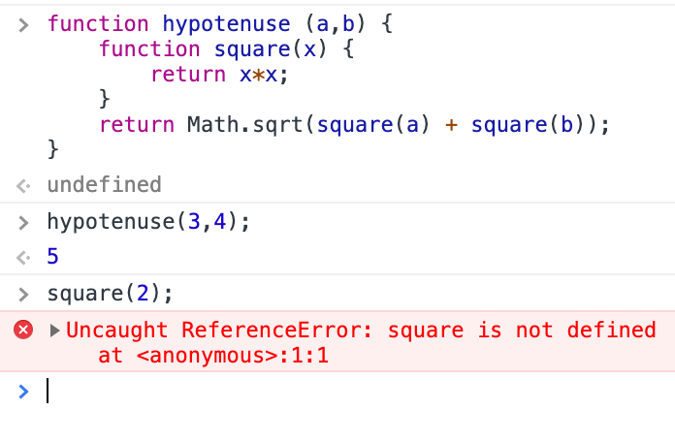

Here I can call hypotenuse function but can’t call square because it is nested. This is applicable to variable.

Closure

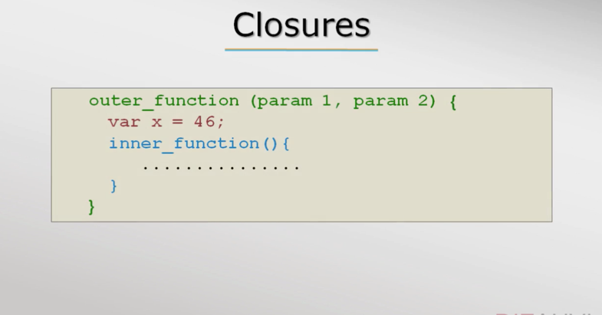

- even when the outer function goes out of scope and the parameters passed to the outer function will be available to the inner function because after all parameters to a function are local variables.

- closure are available in all functional programming language

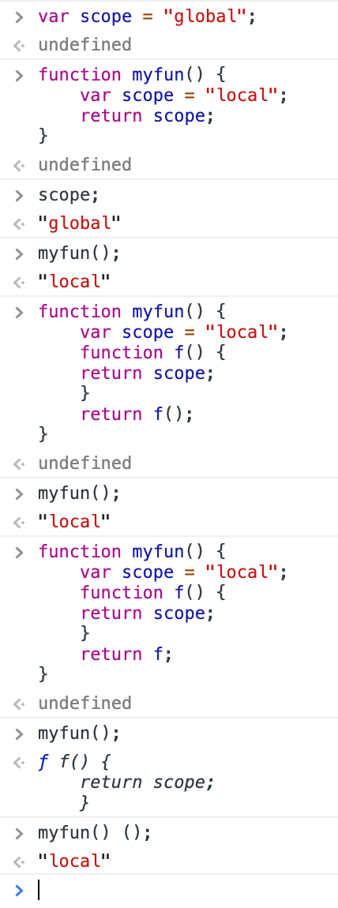

- if no var is loaded inside the function then it checkes global variable

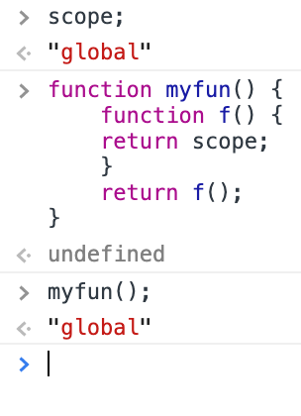

Close example

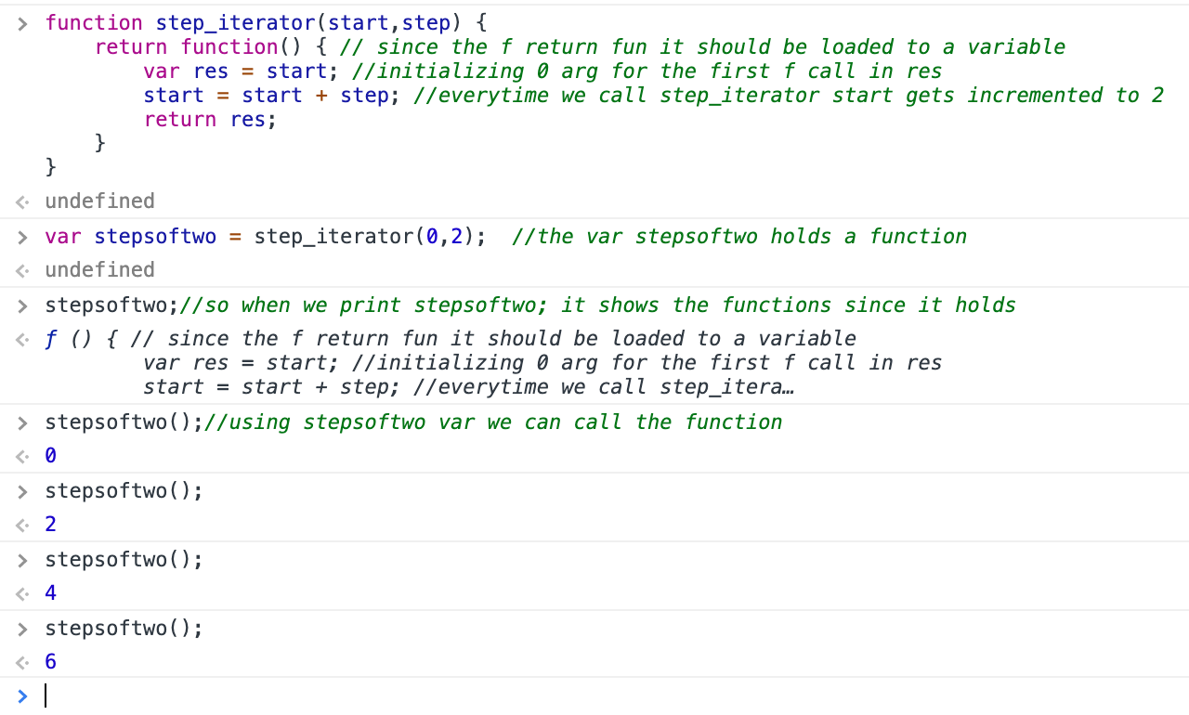

- if we load the same fun in another variable It will start from 0 step

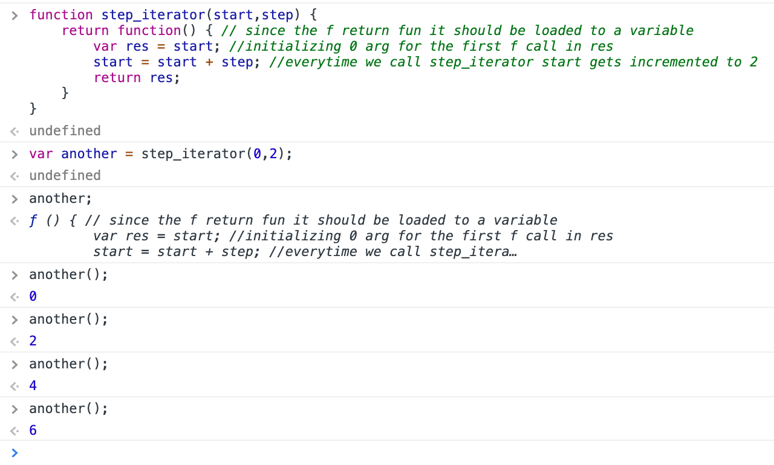

List comprehension

- in many programming languages collection of data or set of data is called as list.

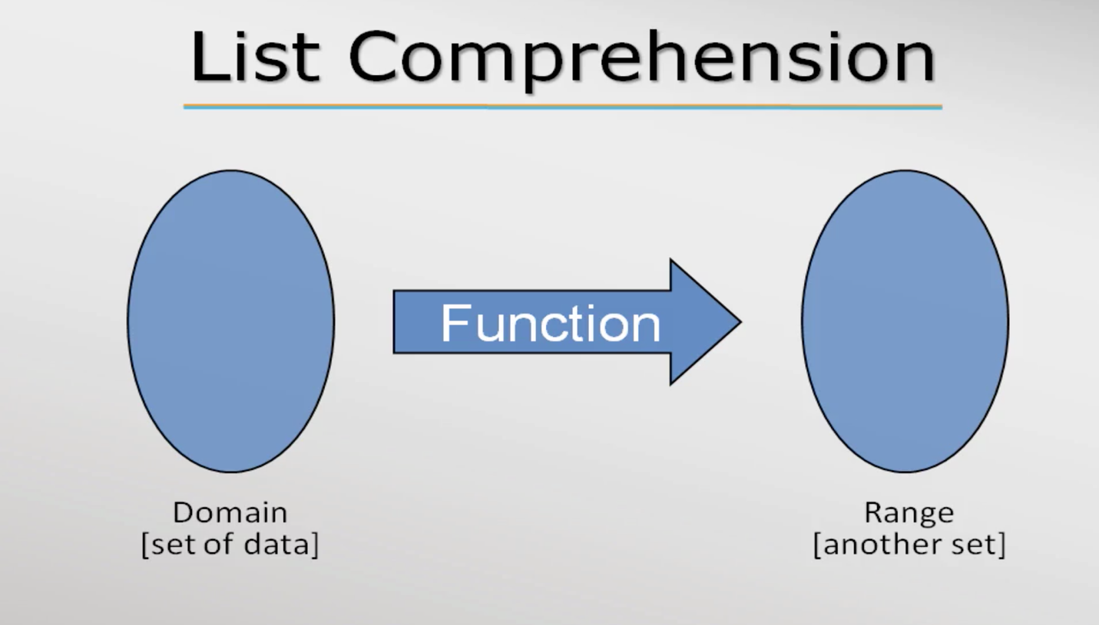

- JS supports 3 list functions,

- filter

- map

- reduce

- List comprehension is basically a feature provided by programming languages to ease the work of developers.

- these list comprehension works on array

- filter function

[2,4,5,6,12,15] 🡺filter🡺 [2,4,6,12]

Filter function take another function as argument it can be anonymous or normal functions



- The anonymous function passed as argument in filter() is called callback function

Callback function syntax:

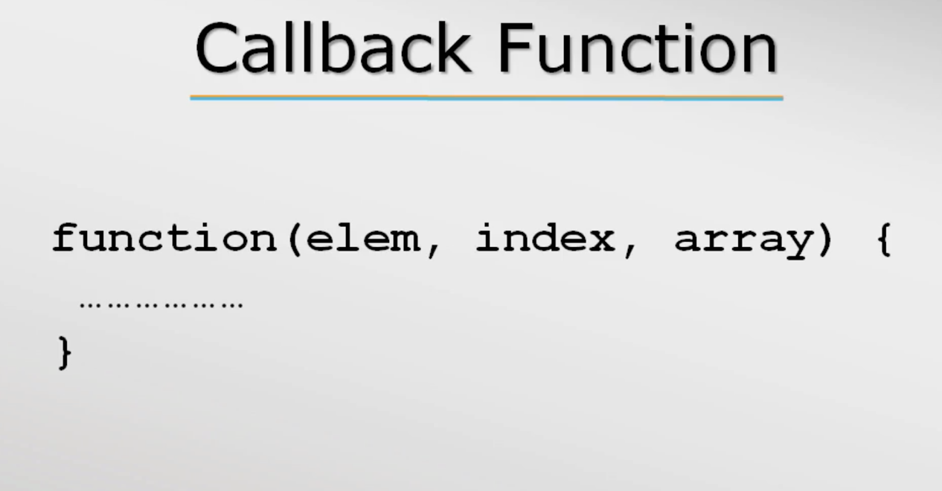

*Callback must return a Boolean value for filter function.

-In call back if only one argument is passed in place of 3 the other 2 are considered as undefined by JS

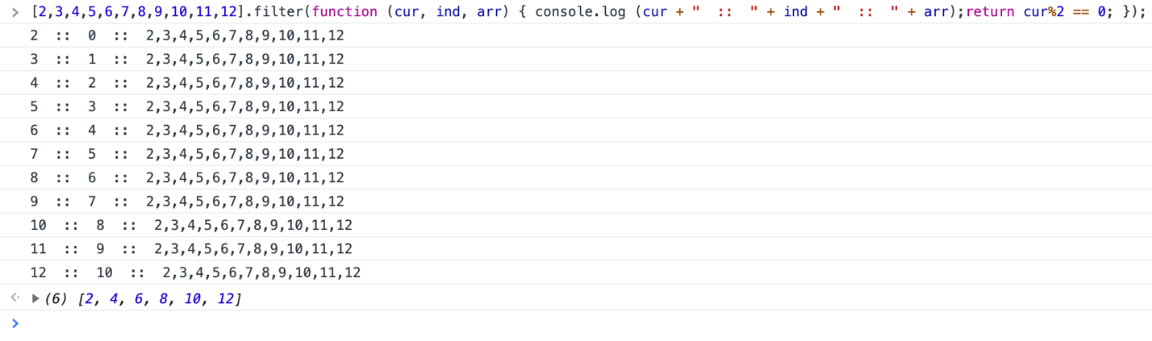

- map function

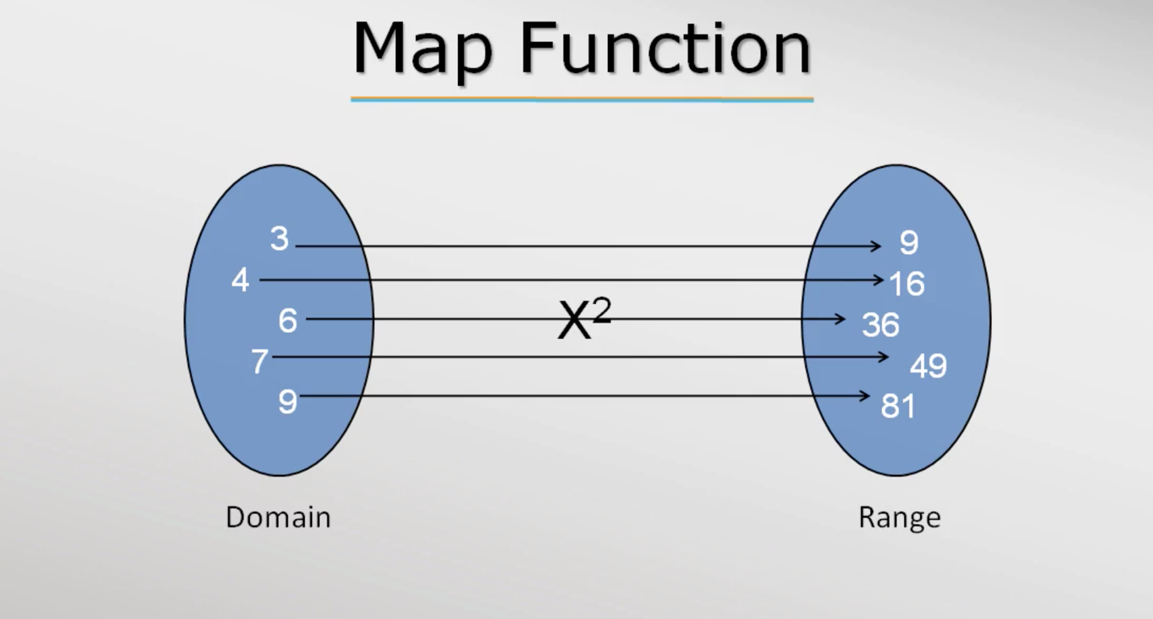

Ex:

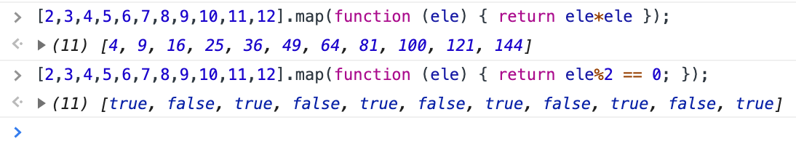

*callback function is similar to filter but it will return a value corresponds to the input.

- reduce function

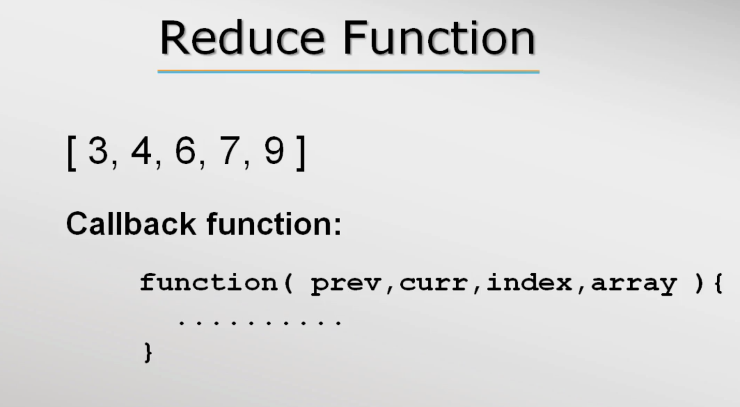

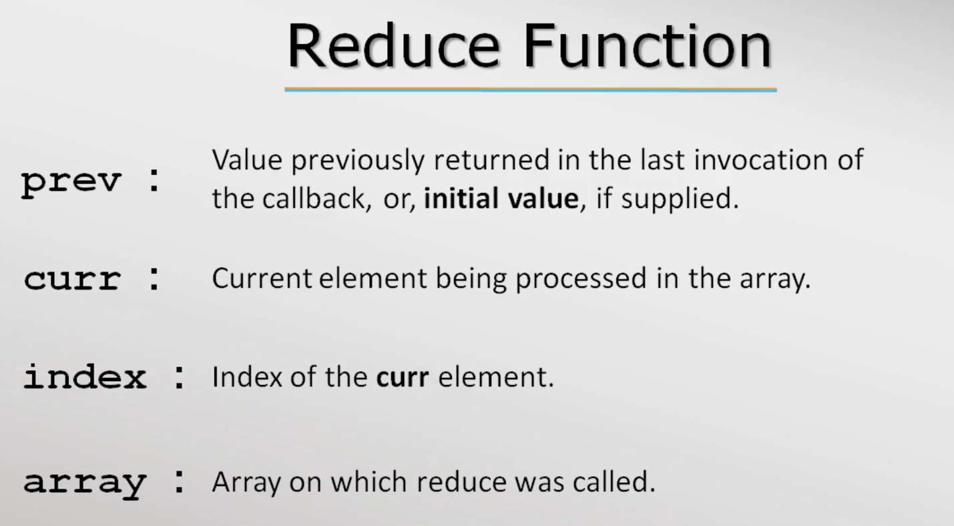

Ex:

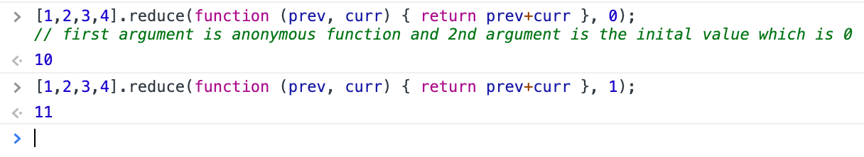

Explanation:

Call 1

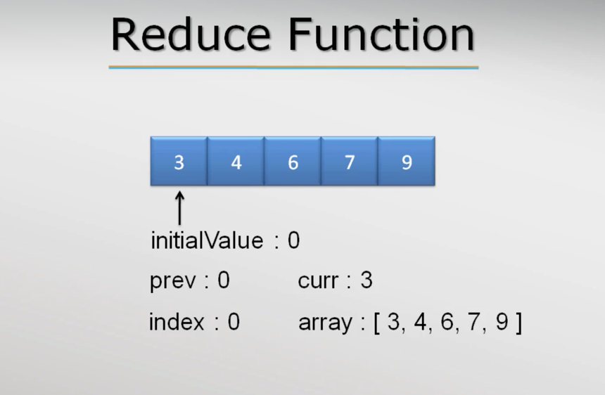

Call 2

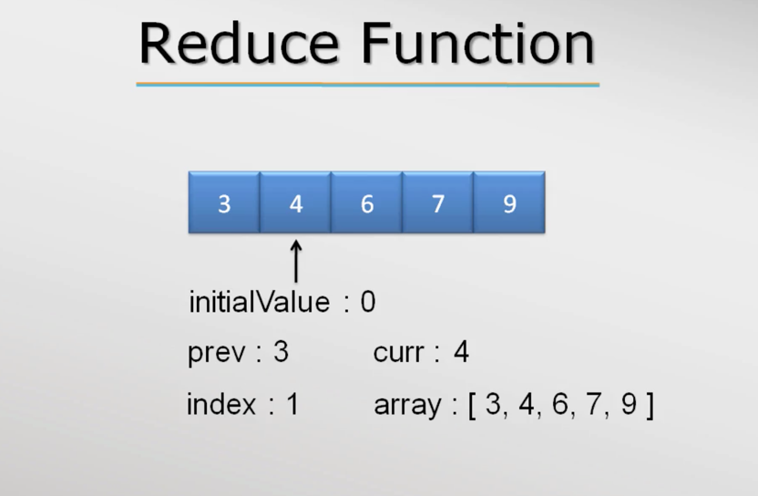

Call goes till it reaches the last ele

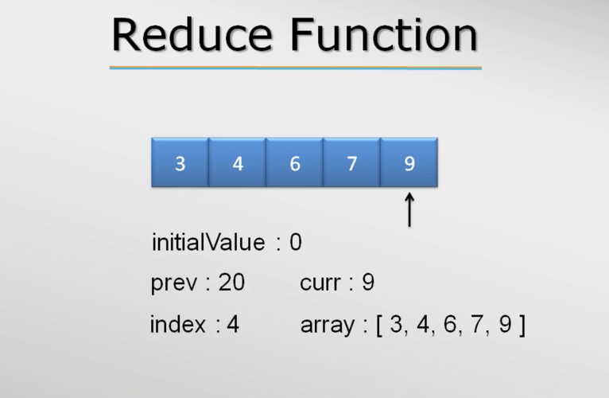

Ex: In the below rest of the arguments were logged

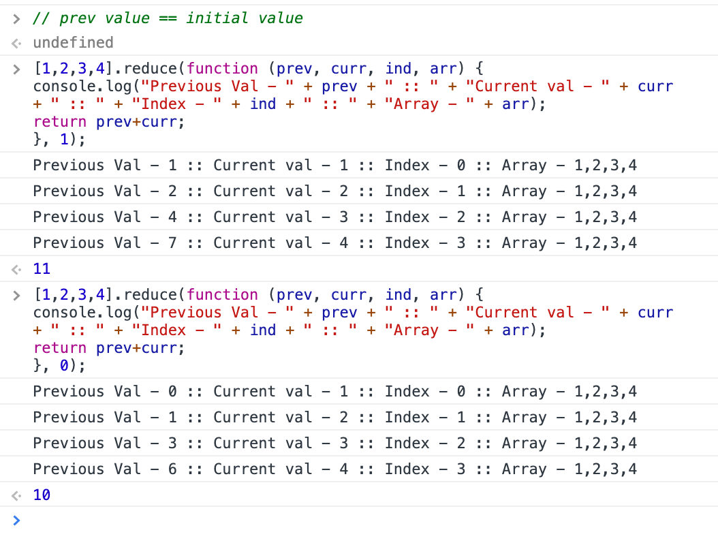

Ex: sum of natural numbers using reduce while the input is number

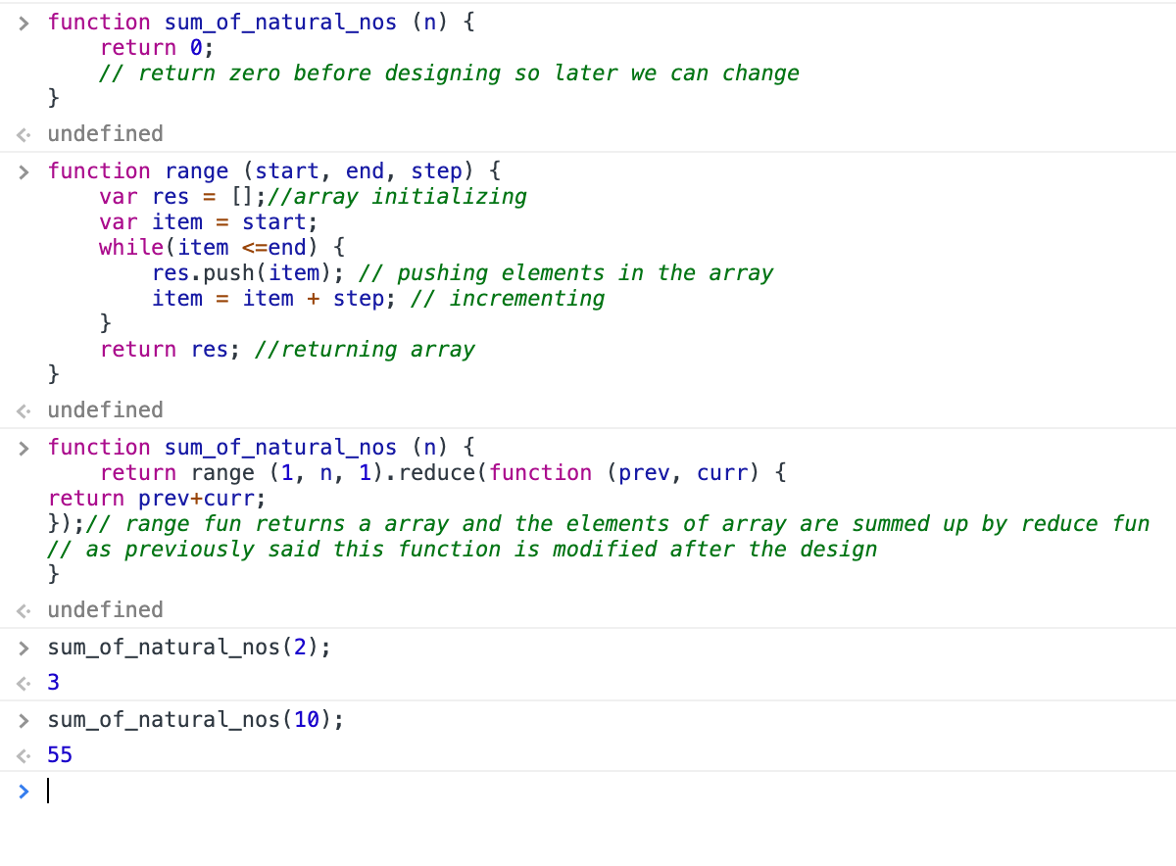

Accessing variable numbers of arguments

- JS has inbuilt arguments object which is array like but not really an array. It will help to get the arguments passed in a functions and list them like array(not exactly array) even if parameters are not defined in the function. But we can’t process the arguments since they aren’t array. The bellow screenshots will give clarity,

Screen shot 1:

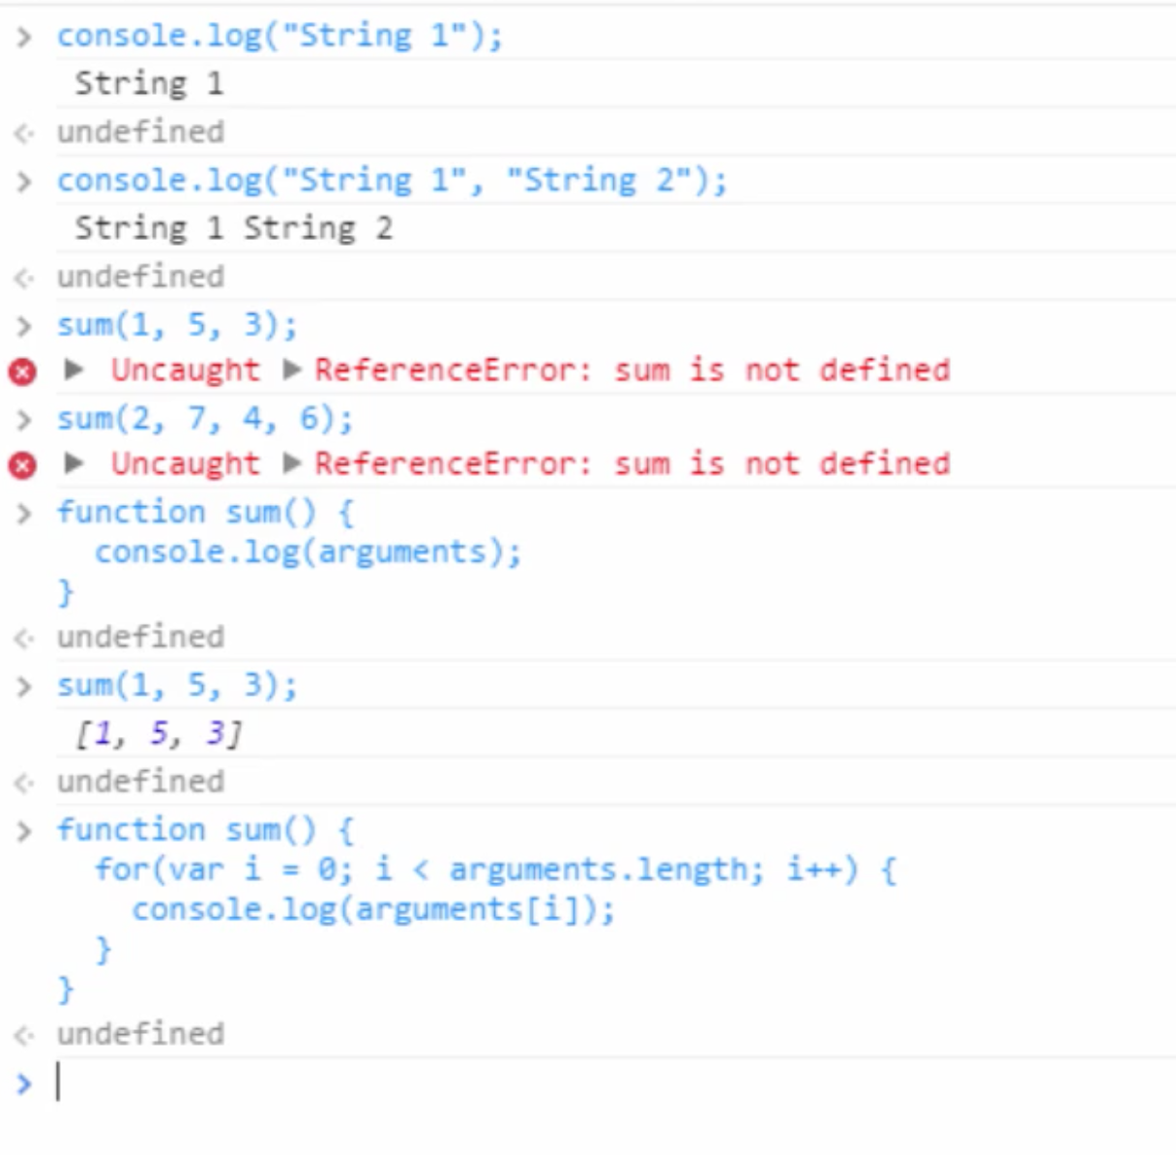

Screenshot2:

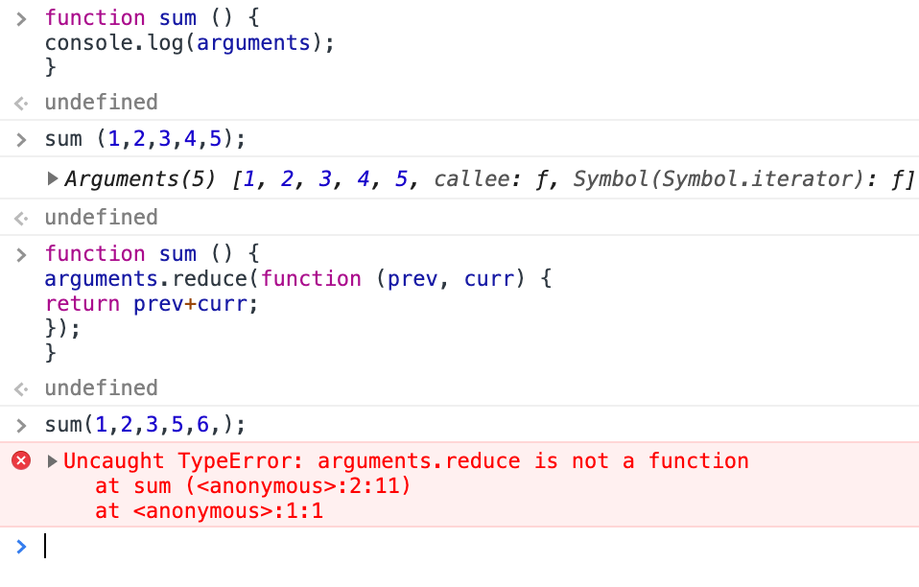

To use the argument as array we need to process it first below some more things we explained so read the comments

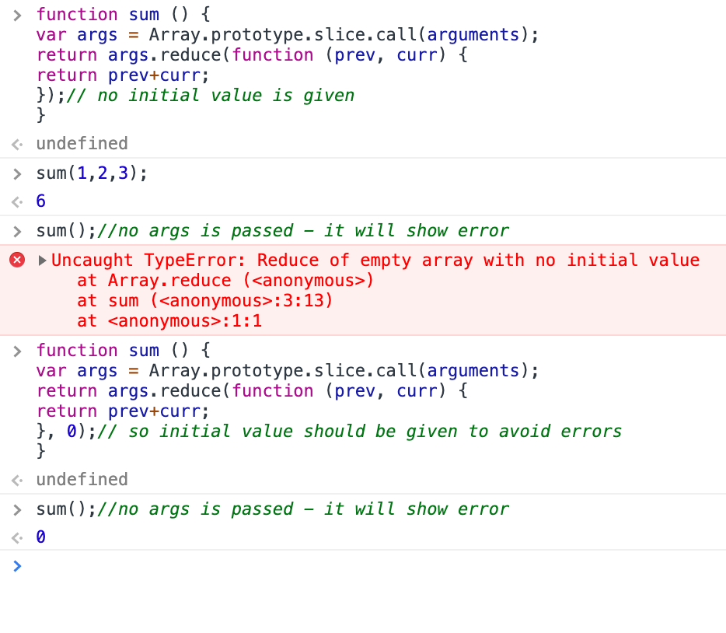

Object Oriented Programming

Coverage

- Functions as object

- The “this”keyword

- Writing custom types

- Prototype based inheritance

Functions as objects

Creating a typed object

- Java and C#(C sharp) are class based object orientation so class name is used as a custom type for object creation.

Ex: Class based OO

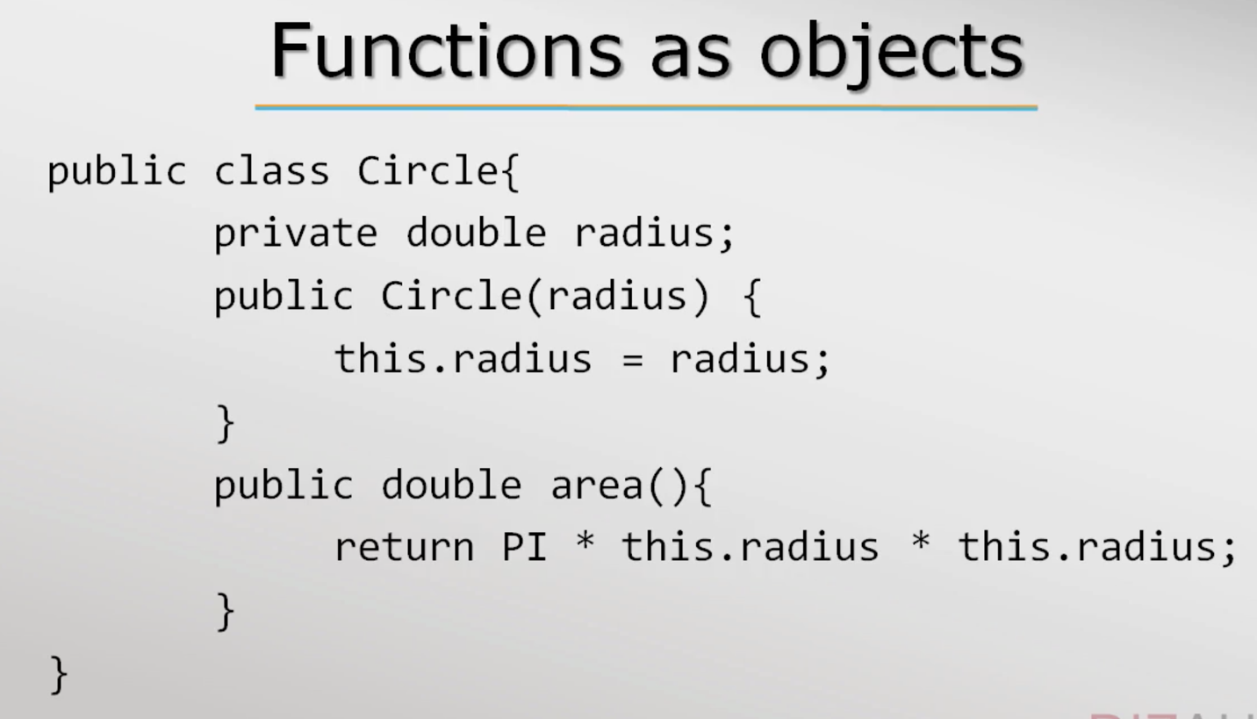

So to create an object for the class circle we need use the class name as type, In the example above Circle is the type and object declaration would be like this in Java or C# 🡪 Circle obj = new Circle(); // Circle is the type, obj is the object name and Circle() is the constructor that initialize members of the class Circle

- JS is a prototype based OO so there are no classes just object, which is a dictionary kind of data structure. Functions are like objects in JS hence object can use function as value to its properties like the example below,

Ex: Object initialization with a function as a value to its property.

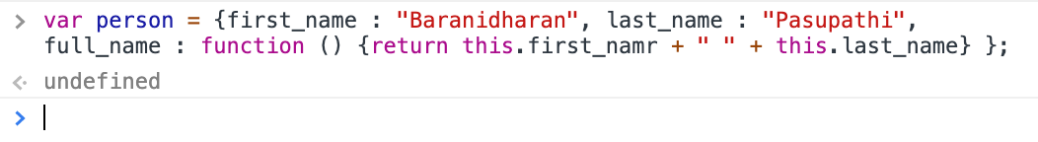

*to avoid run-time errors, “this” keyword should be used in functions that are inside an object.

- The object “person” created above is a general way of object creation. Object creation using functions is a specific way of creating custom type objects like the one shown below, which uses a new keyword to create object.

Ex: Object creation with specific type using function with the help of “new” keyword

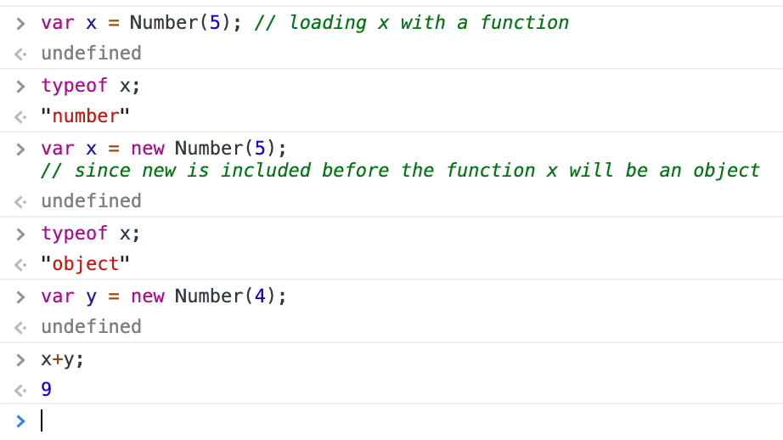

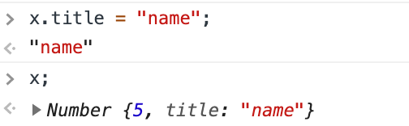

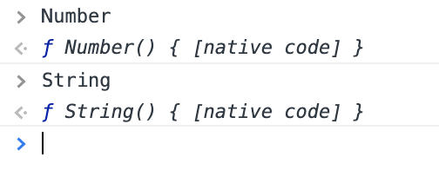

Ex: Objects can also be created using user defined function

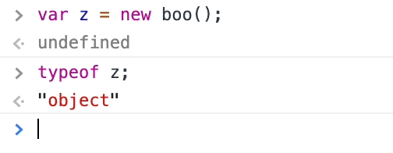

The “this” keyword

Concept of this keyword

- In Java “this” is bound to the current object but in JS “this” is bound to different objects based on context in which it is used. Also, the bound varies with strict or non-strict mode. Mostly JS code is not written is Strict mode.

Contexts the this bound is used,

- global context

- function context

- simple function

- method on an object

- constructor function

- Global context: “this” is used outside any function.

Ex: Logging “this” in console and it shows that refers to window, which is a global object

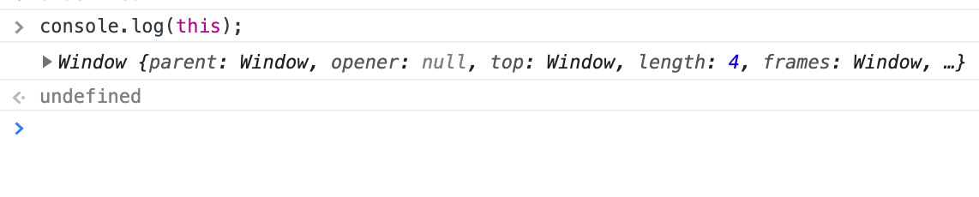

- function context: “this” is used inside a function and there can be many cases that “this” is bound to.

-- simple function

Ex: this is different contexts

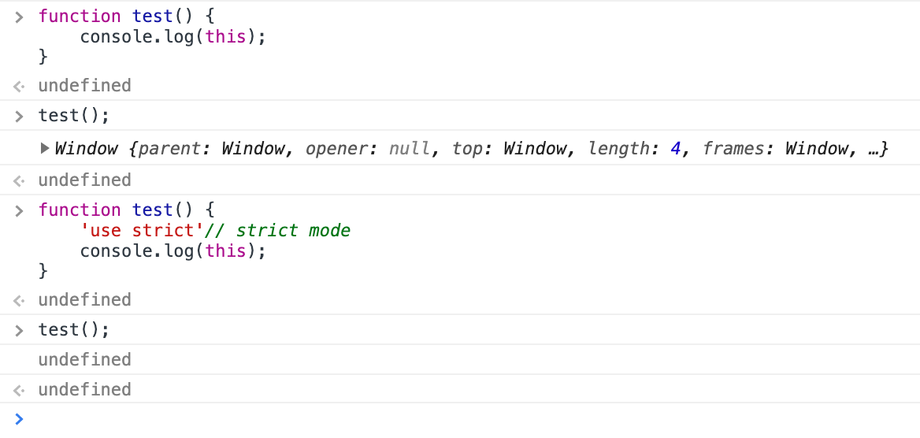

-- Method on an object

Using this in a method, in which the method is a value of an object.

Ex: interpreter throws error when this isn’t used in the function but when used it doesn’t. This means the “this” parameter is bound to aCircle object, when the aCicle function is called up on.

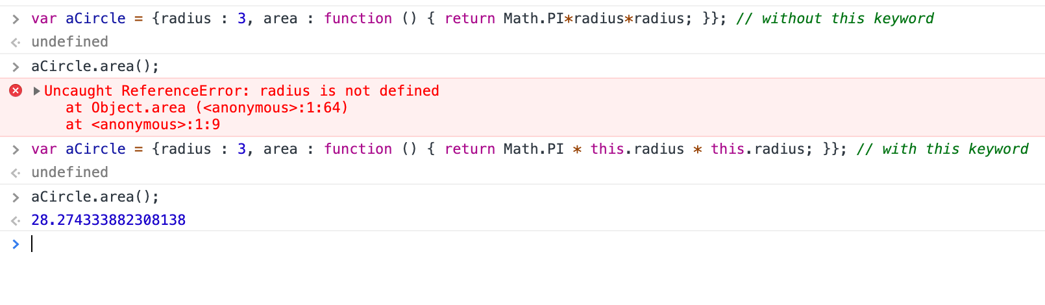

Ex: advantages of dynamically typed languages: *references do not matter at compile time rather at execution time.

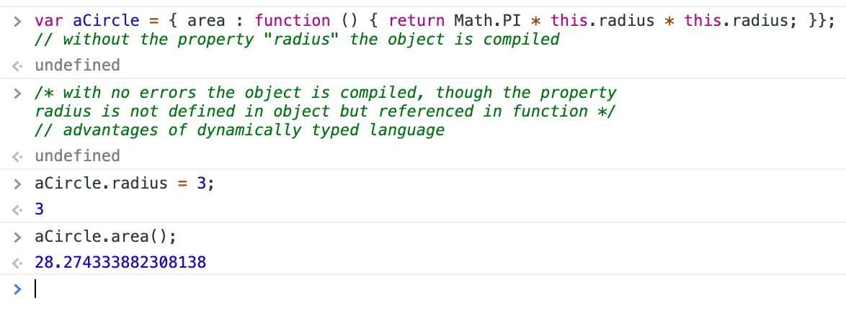

Ex: assigning test function, which logs “this”, to the aCircle property “f” but the test function is already defined outside of the object and invoking the property “f” will print the object aCircle. Since the function is called through the object aCircle. So it is bound to aCircle.

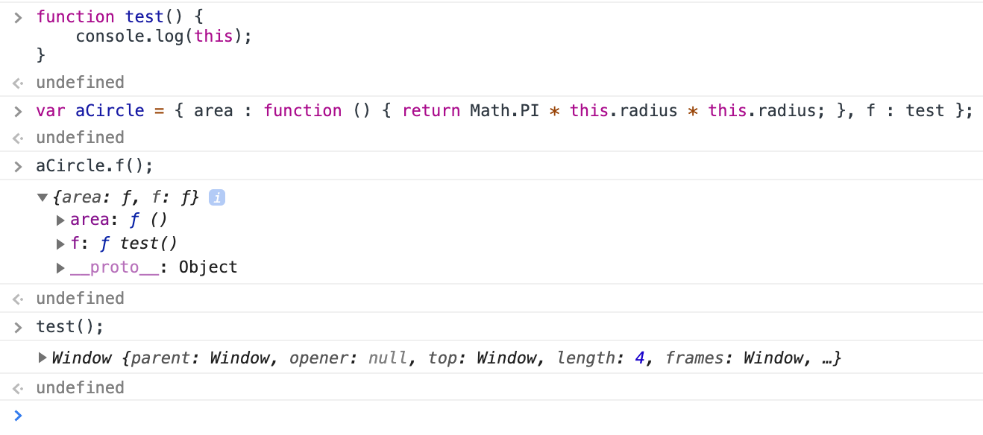

*the idea above is heavily used in DOM (Document Object Model) manipulation

*The Document Object Model (DOM) is a programming API for HTML and XML documents. It defines the logical structure of documents and the way a document is accessed and manipulated.

- Constructor function

JS objects can be initialized in many ways and one such way of initialization is using constructor function. JS provides a template to create objects such templates are called constructor functions. Similar like normal function but the constructor function name should start with a capital letter and that its convention. To initialize an object use new keyword in front of constructor function as shown below,

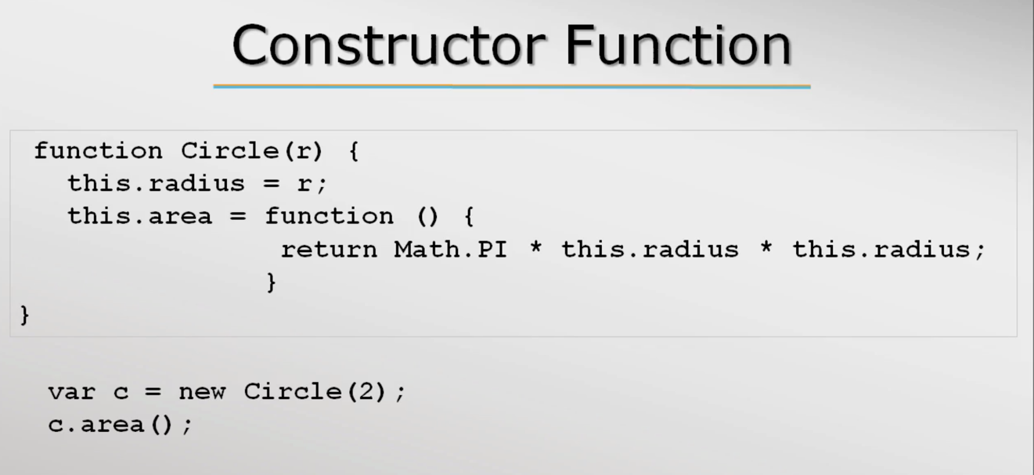

Ex: Constructor function declaration

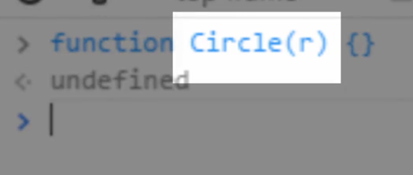

>function Circle (r) { } // empty constructor function with parameter r

<undefined

> var c = new Circle(2); // object initialization

<undefined

>c; // c is an object instace

< Circle {} // empty object

< function Circle (r) { // to pass variable to the object “this” keyword is used

this.radius = r;

}

<undefined

> var c = new Circle(2);

<undefined

>c

<Circle {radius: 2}

>function Circle (r) { // a function is created inside this constructor function

this.radius = r;

this.area = function () { return Math.PI * this.radius * this.radius; };

// this is used in area function to tell JS radius refer to the Circle object

}

<undefined

>var c = new Circle(2);

<undefined

>c

<Circle {radius: 2, area: f}

>c.area

<f () { return Math.PI * this.radius * this.radius; }

>c.area(); // calling area function using object c

<12.566370614359172

>c.[“area”](); // since area is a property the function call can also be done this way

<12.566370614359172

Naming Convention

Normal functions can be written in lowercase but a way good way is to use camelCase.

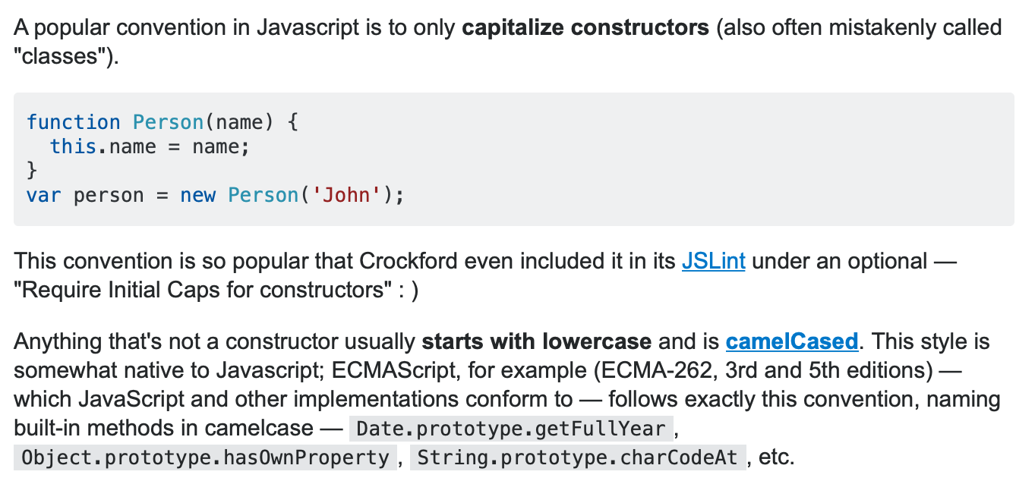

(<https://stackoverflow.com/questions/1564398/javascript-method-naming-lowercase-vs-uppercase>)

Using Prototype property

Prototype property will add a property to an object, but this property can be accessed by all the object instances which was previously created.

Ex: Prototype property

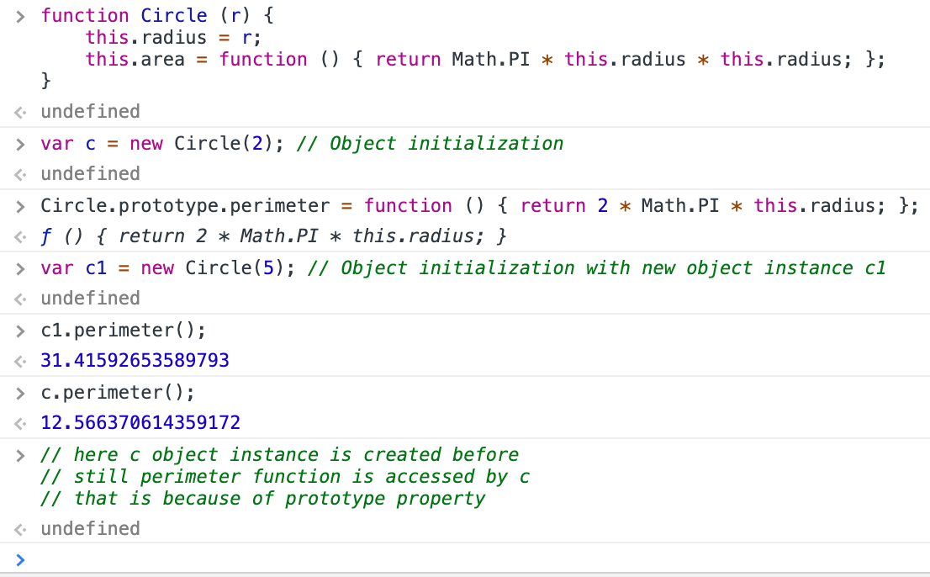

Inheritance using property

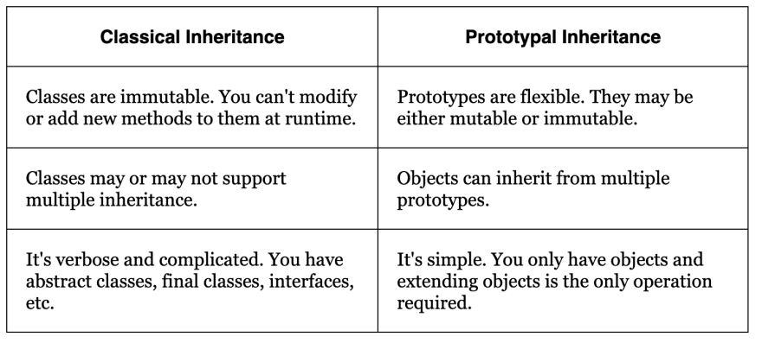

Ex: prototype inheritance

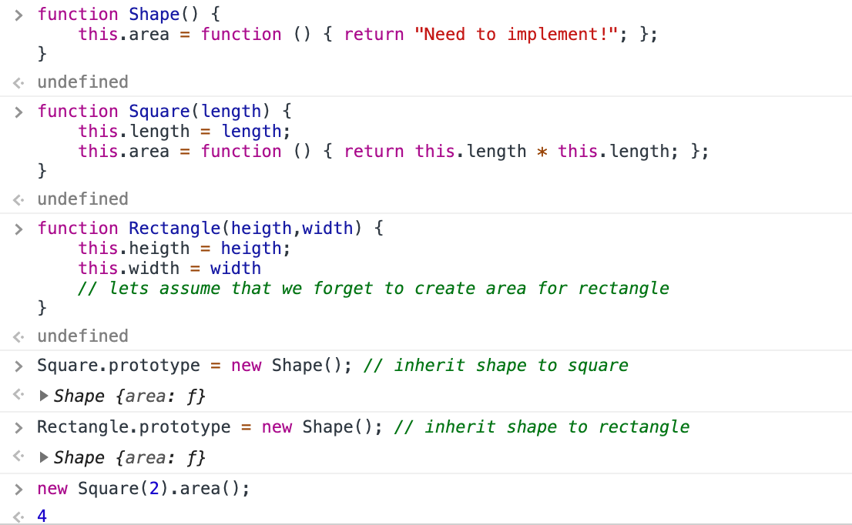

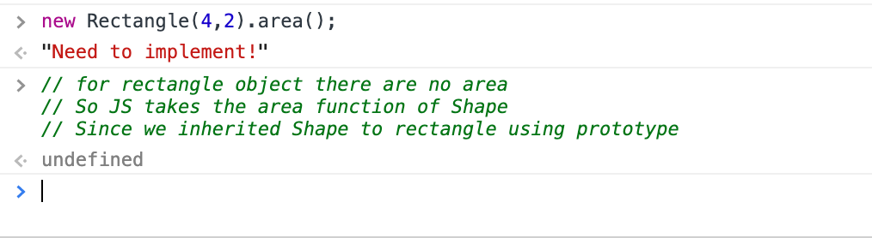

Miscellaneous

Coverage

- Error handling

- JS Events (Event model: JavaScript's interaction with HTML is handled through events that occur when the user or the browser manipulates a page. When the page loads, it is called an event. When the user clicks a button, that click too is an event. Other examples include events like pressing any key, closing a window, resizing a window, etc. Events are a part of the Document Object Model (DOM) Level 3 and every HTML element contains a set of events which can trigger JavaScript Code.)

- DOM (access and manipulate html pages through DOM api)

- AJAX (Ajax is a set of web development techniques using many web technologies on the client side to create asynchronous web applications. With Ajax, web applications can send and retrieve data from a server asynchronously without interfering with the display and behavior of the existing page.)

- How browser works

*Sync vs Async: An asynchronous application is where some or all of the requests are made to the server(s) but control is returned to the user immediately. ... In a synchronous application the user is prevented from performing additional input until the server responds.

Error handling

*All programs during execution may land in a situation which is not normal and may denote an error condition. Programmers are supposed to make sure that they handle these conditions gracefully and don’t make their programs crash.

- JS has exception-based error handling mechanism – Simply, when a code runs into problem it can raise an exception.

- Handling of these exceptions is called catching.

Ex: Error handling

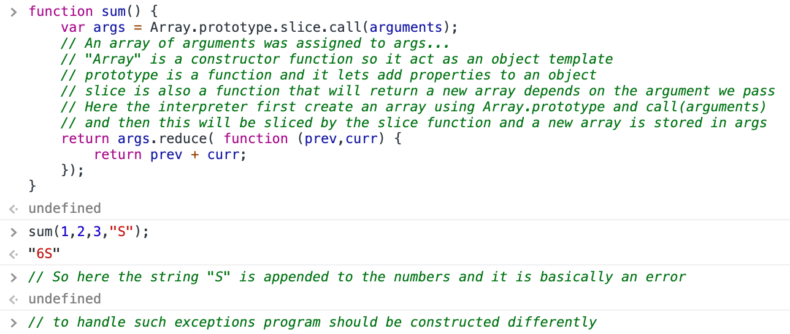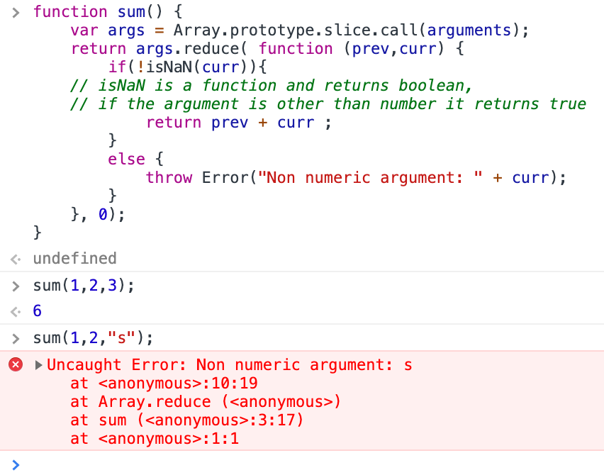

Ex: When the error occurs, the program stops it execution

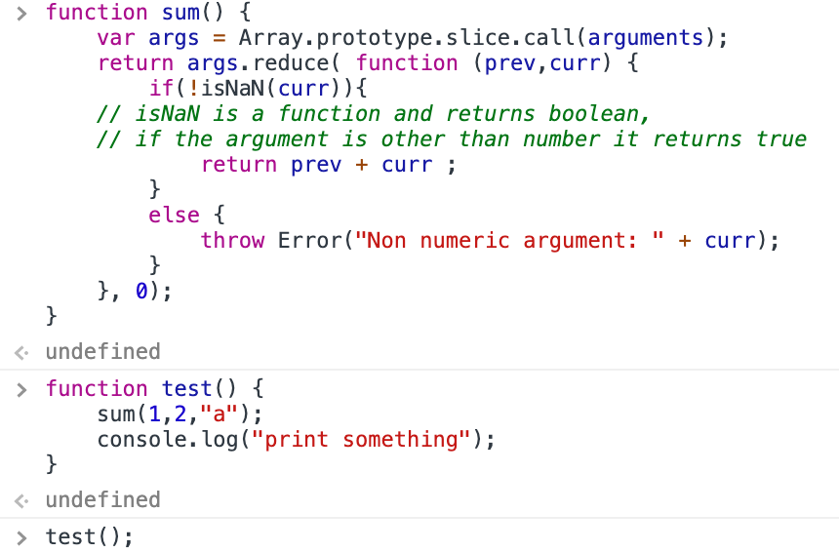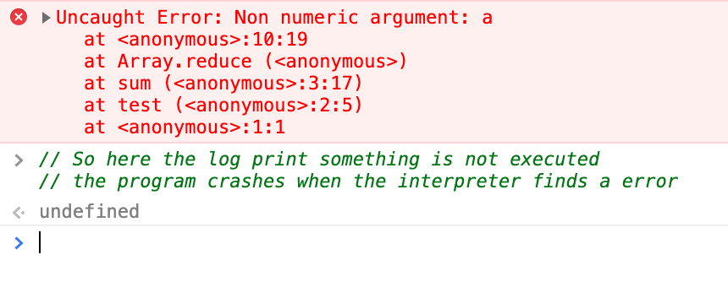

Ex: To finish the execution smoothly as well as catch errors, use try and catch technique

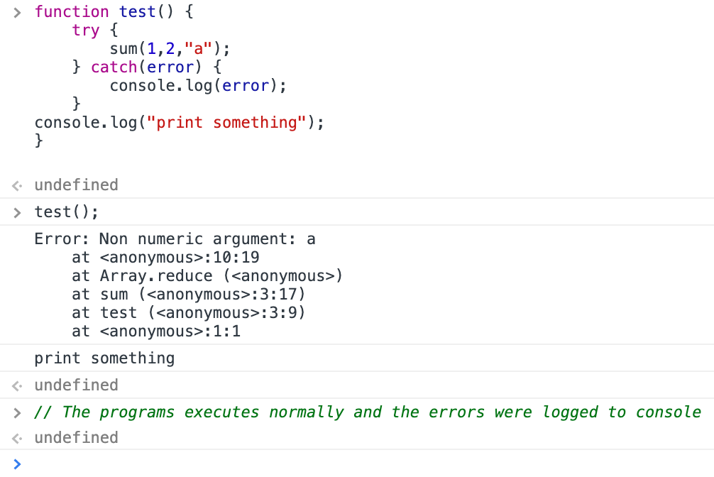

Debugging

Most browser consoles provide a debugging environment to identify bugs in the code in a step manner.

Breakpoints are the stop points and it is a feature which is available in consoles to debug web apps. Basically, these break point should be enabled in the source code this will halt the execution of the program.

Chrome console provides lots of tool for debugging.

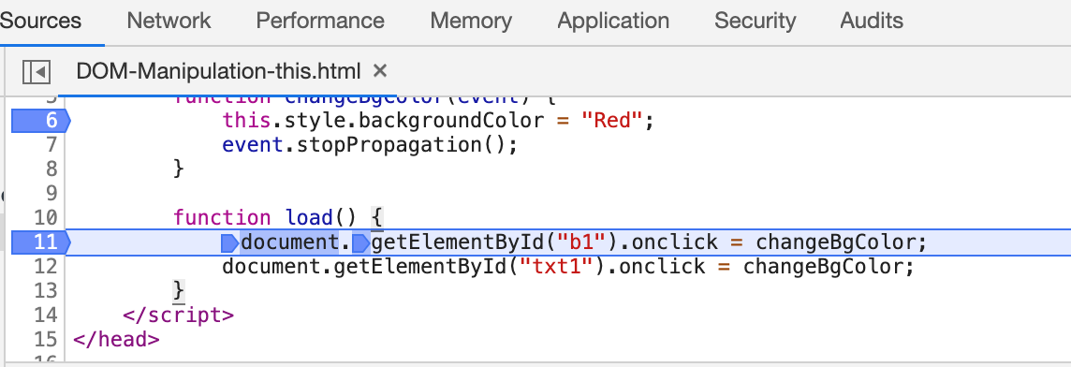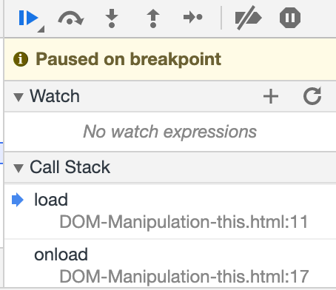

DOM

The Document Object Model (DOM) is a programming interface for HTML and XML documents. It represents the page so that programs can change the document structure, style, and content. The DOM represents the document as nodes and objects. That way, programming languages can connect to the page.

A Web page is a document. This document can be either displayed in the browser window or as the HTML source. But it is the same document in both cases. The Document Object Model (DOM) represents that same document so it can be manipulated. The DOM is an object-oriented representation of the web page, which can be modified with a scripting language such as JavaScript.

DOM Working

HTML is a document and when the browser gets the HTML content it parses it into a tree like structure before displaying it to the user. This tree structure is called DOM because it gives object like structure to the HTML.

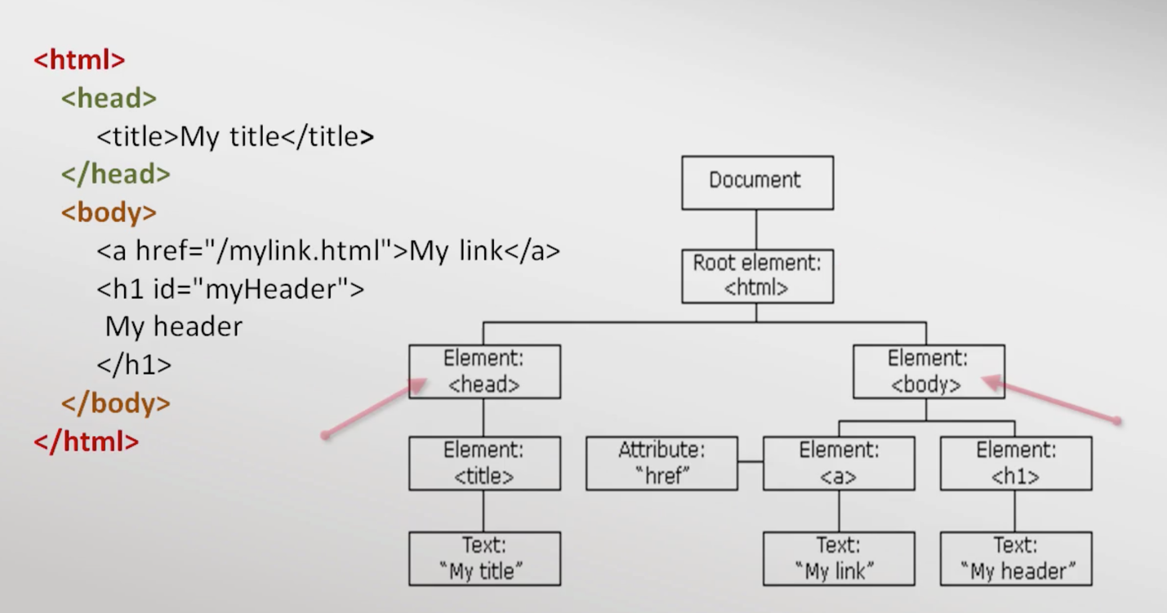

- There are 12 different types of nodes in DOM.

- The above screenshots show Element, attribute and text nodes. Obviously, Text nodes won’t point to any nodes and this node is called leaf node. Any node that has no child node becomes a leaf node.

- Child nodes having a same parent node are called sibling nodes.

*Nodes

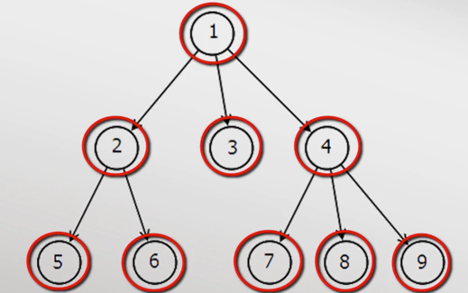

JS and DOM

- JS provides a document object which contains HTML DOM object.

- “document” global variable is the entry point of DOM interface.

- To utilize DOM feature JS provides document object which has the property of DOM

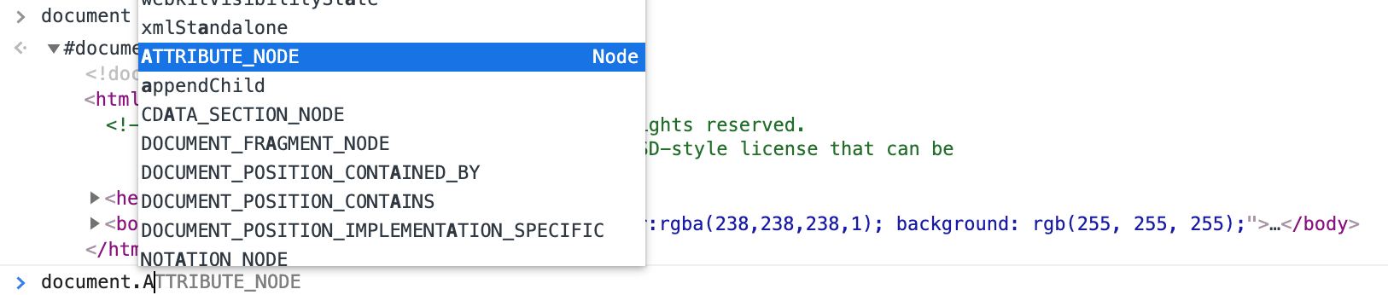

Ex: Accessing root html elements

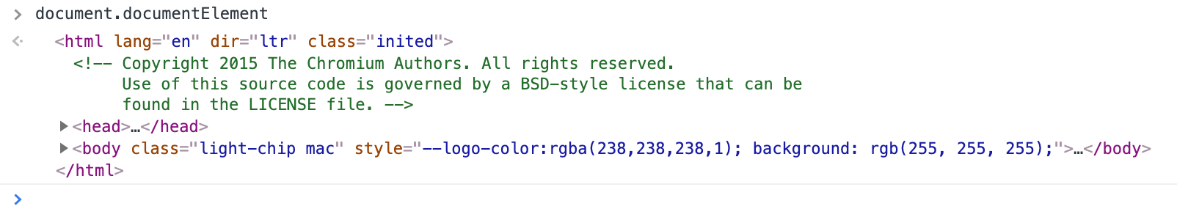

- “document” object refers to Document in the tree structure while the “document element” refers to Root element.

- Commonly preferred way to access an document element is by its ID: document.getElementById(“id”);

- Using document.getElementById method to change the src attribute of img element

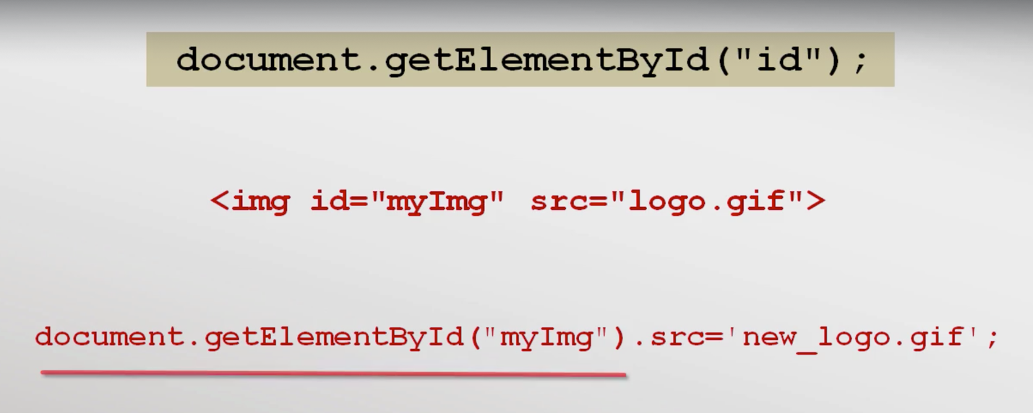

- Adding custom attributes to an element but these are ignored by the browsers. This is how frameworks are written by adding their attributes. Ex angular uses ng-... as their convention.

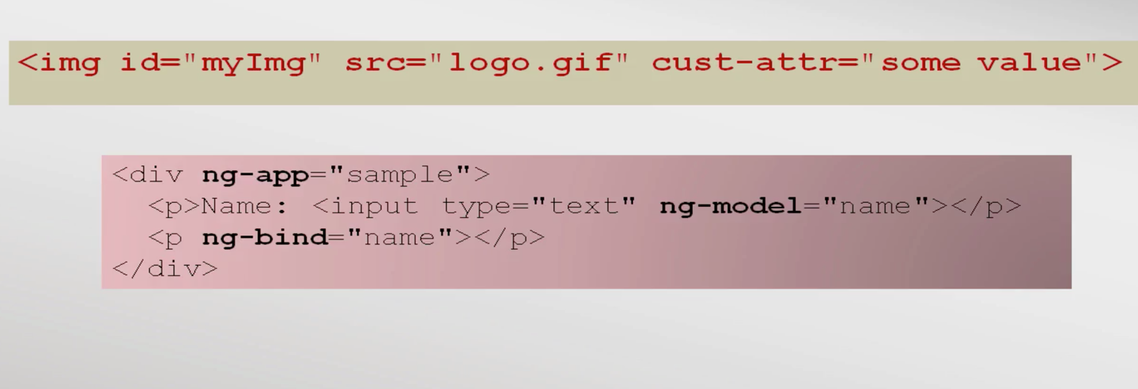

- DOM api validation on custom attributes.

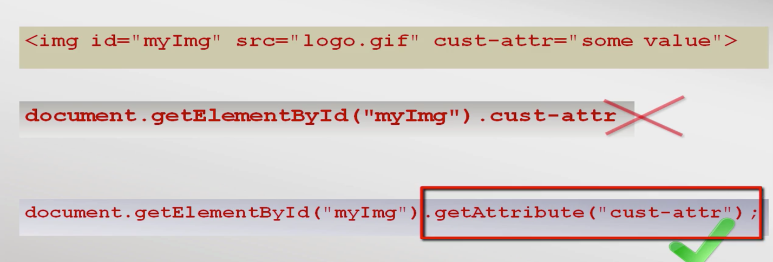

- DOM API provides properties to access Child nodes in many different ways as shown belowa

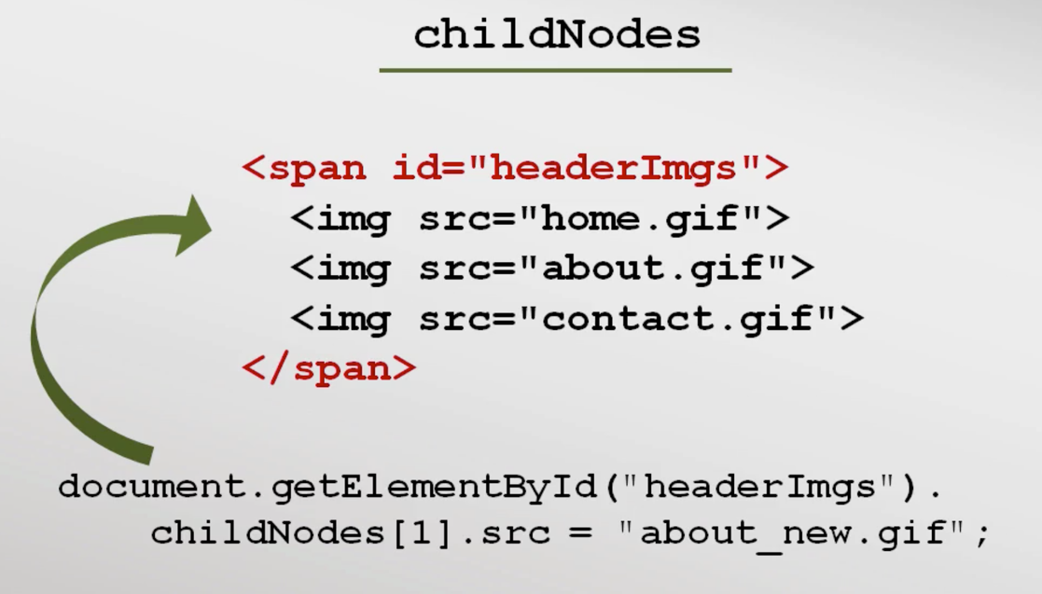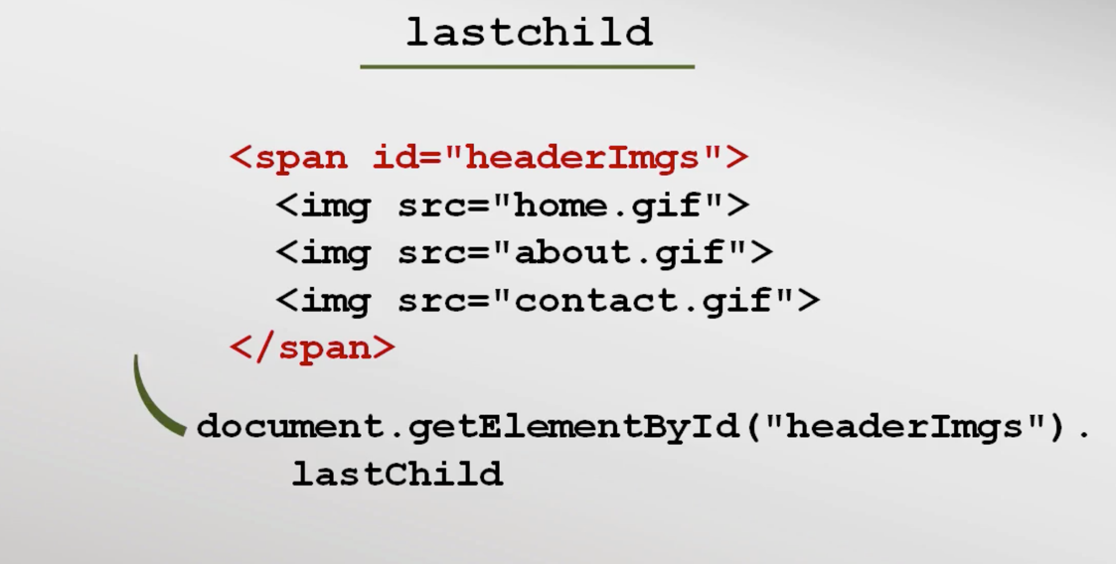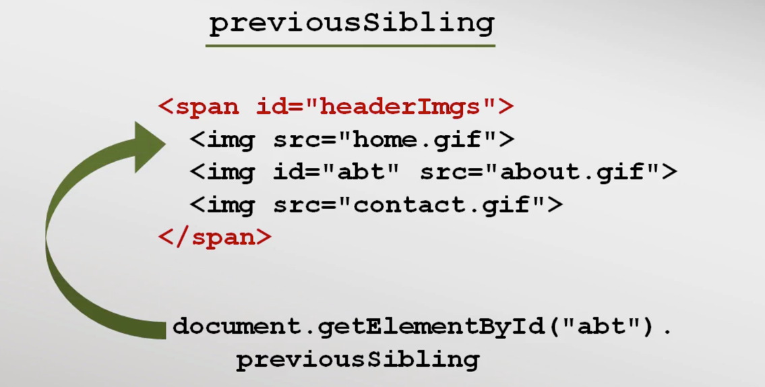

- DOM api provides a lot of methods like getElementByName(), getElementByTag() etc. These methods can be used depends on the site requirement.

- Thought DOM interfaces are standard there are differences in implementation between major browsers. So most of time frameworks like jQuery is used to eradicate cross-browser issues.

‘setTimeout’ Function

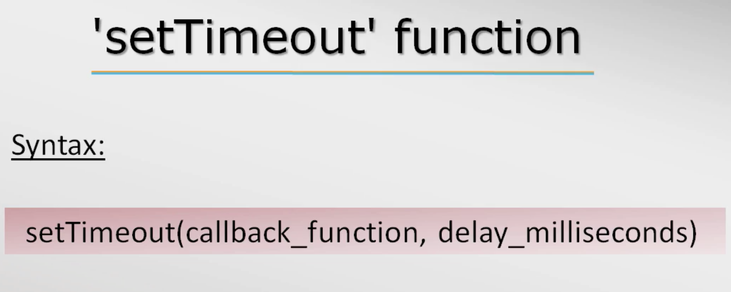

>setTimeout(function () { console.log(“should print after 2 seconds’); }, 2000);

<1

Should print after 2 seconds

>// the 1 printed is an ID, that can passed in the clearTimeout() method to cancel the timer

>undefined

> setTimeout(function () { console.log(“should print after 7 seconds’); }, 7000);

<2

>clearTimeout(2)

<undefined

>

Browser Events

Actions taken inside a browser are generated as events. Activities like mouse movement, mouse click, page load etc. are considered as events. With these events we can attach function to do some desired operations or manipulate a page.

- Instead firing a load function property addeventListeners functions can be used to perform desired function on specific events.

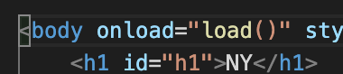

🡨🡪

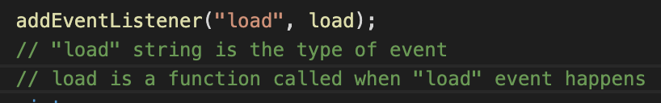

IE8 don’t have addEventListener functions so jQuery or angular frameworks has to be linked for browser compatibility issue.

- addEventListener function can also replace onclick property of document.getElementById() –

document.getElementById(“id_name”).onclick = changeBgColor; 🡨🡪

document.getElementById(“id_name”).addEventListener(‘click’, changeBgColor); // this is just an alternate programming style of doing the same action.

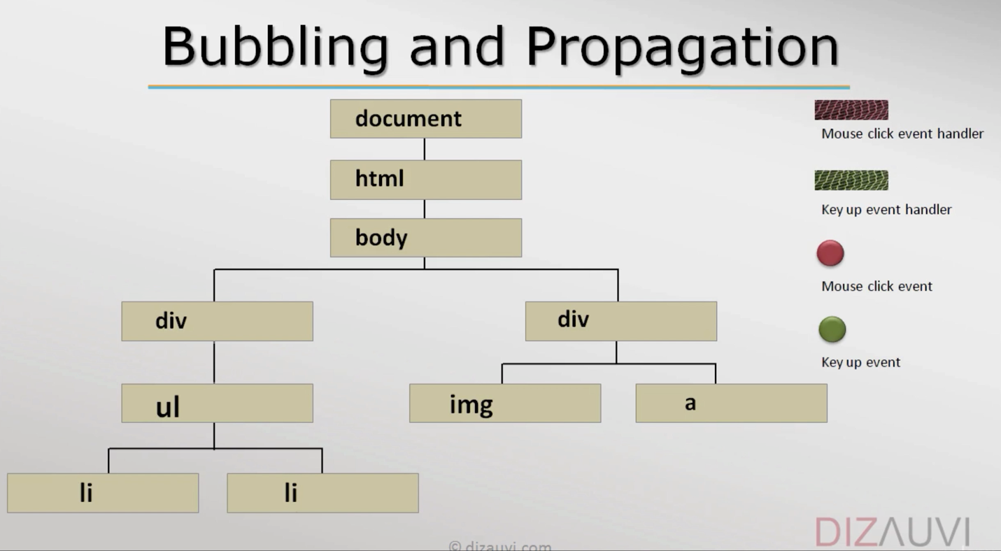Bubbling and Propagation

Event bubbling and capturing are two ways of event propagation in the HTML DOM API, when an event occurs in an element inside another element, and both elements have registered a handle for that event. ... With bubbling, the event is first captured and handled by the innermost element and then propagated to outer elements.

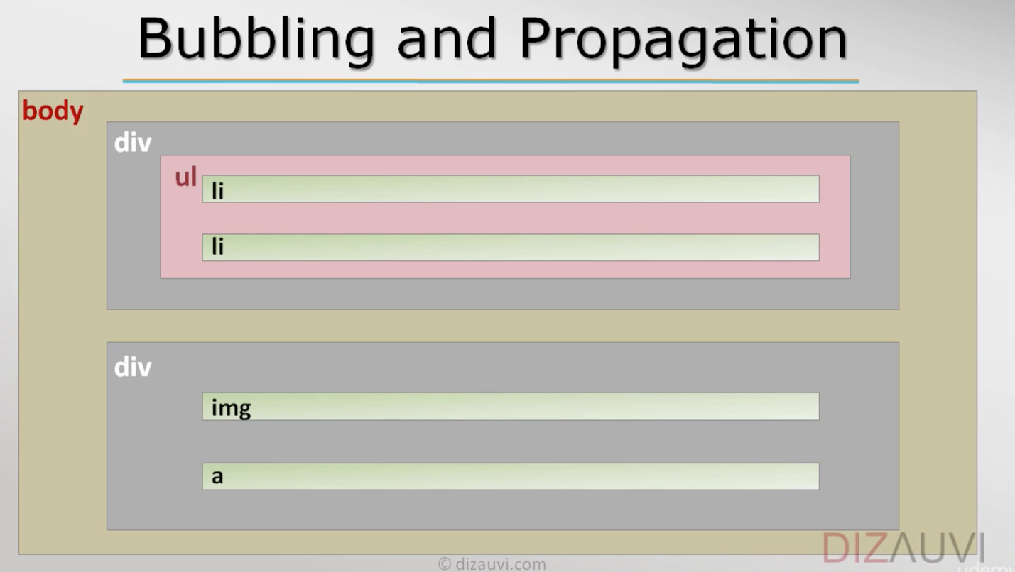

Bubble and propagation resource: (<https://javascript.info/bubbling-and-capturing>)

DOM Event list: (<https://www.w3schools.com/jsref/dom_obj_event.asp>)

To stop the event propagation from child to parent nodes is to use event.stopPropagation(), where “stopPropagation()” is a property in the object “event”.

The Event Object

Event Object Resource: (<https://www.udemy.com/course/programming-in-javascript/learn/lecture/2193332#overview>) and image_canvas.html file

Some event object properties

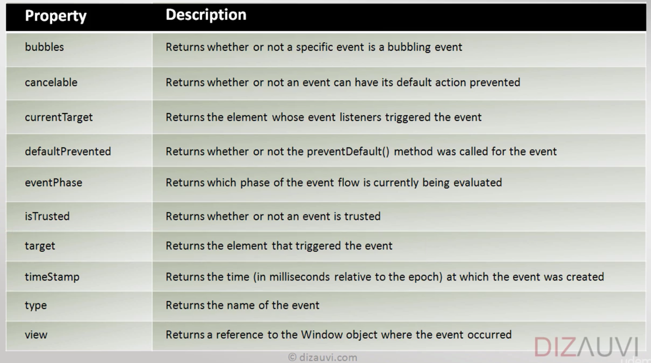

Event object properties which holds method

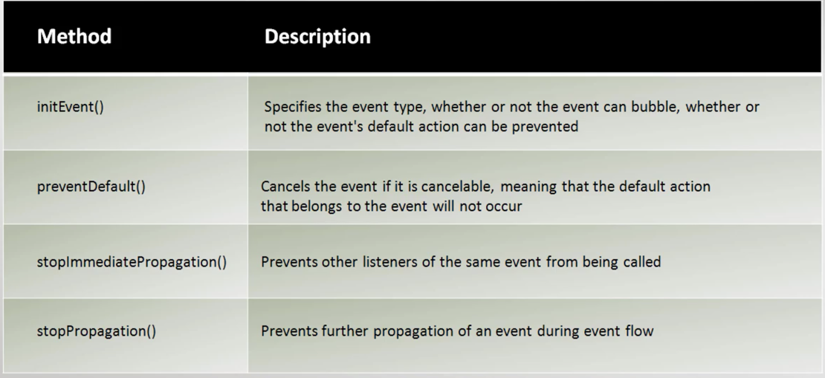

Events types

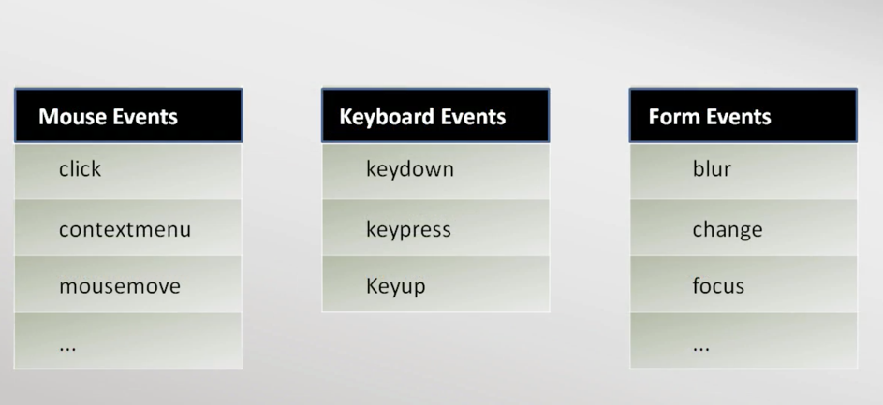

Mouse Events

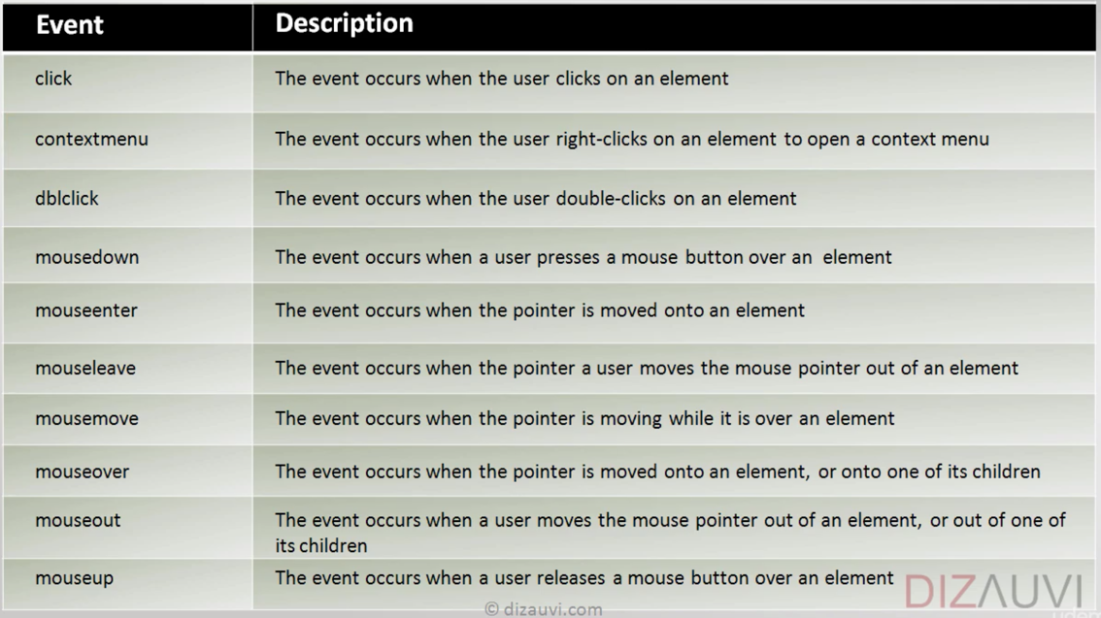

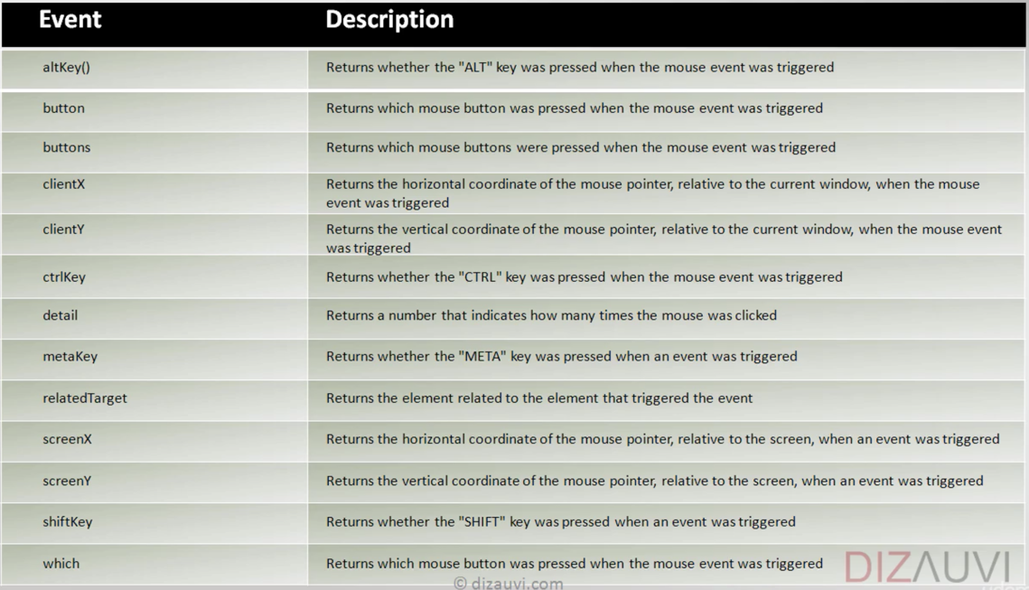

Keyboard Events

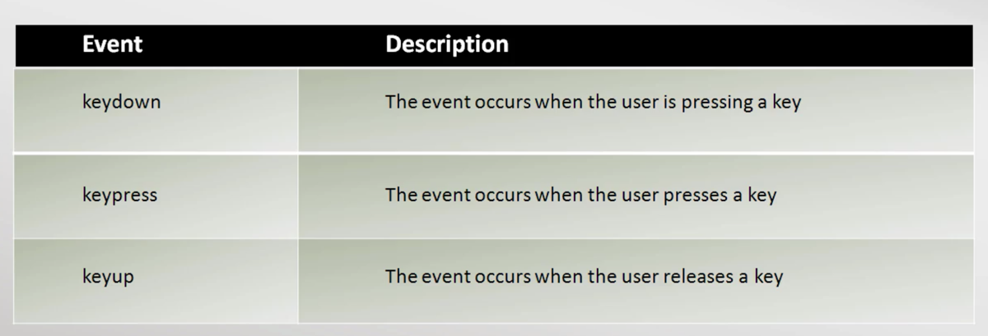

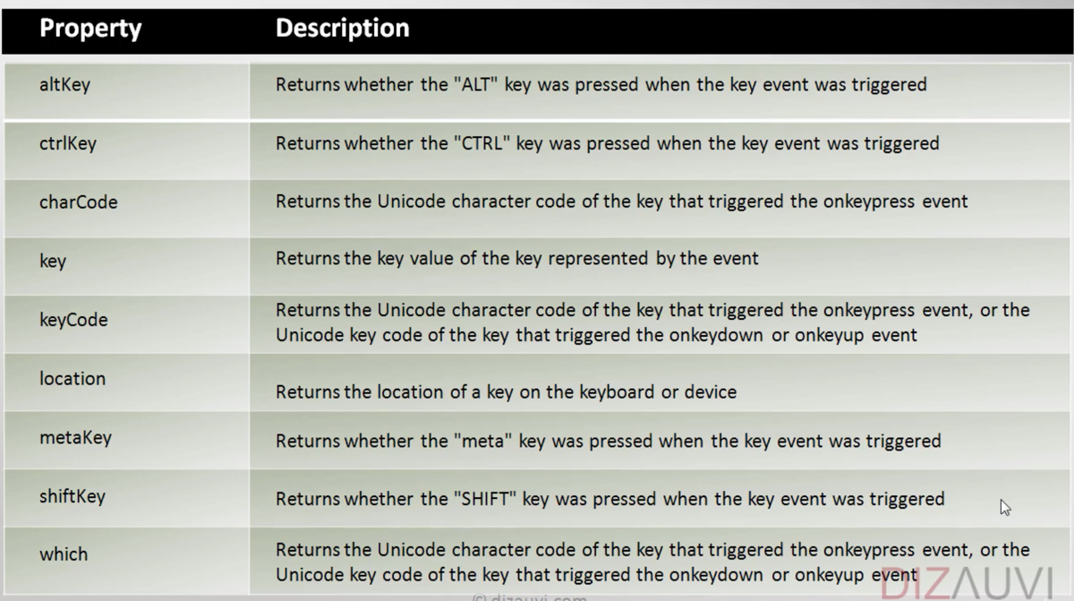

Drag Events

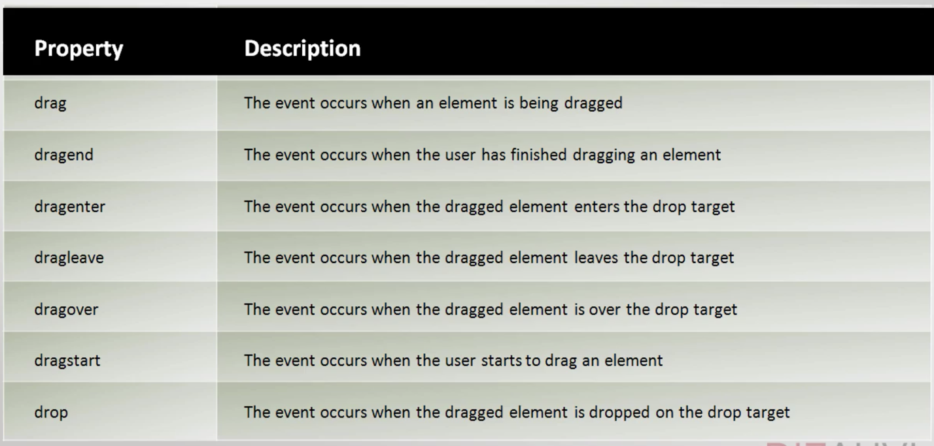

Clipboard events

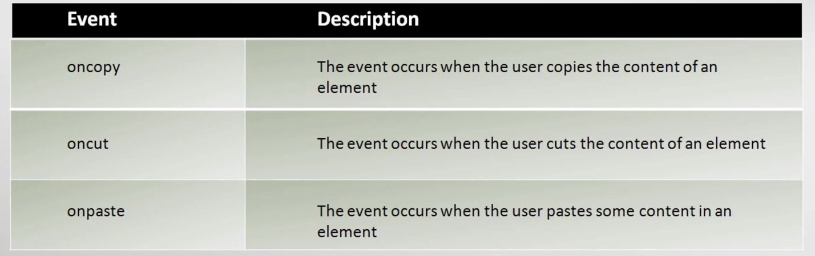

Still there are lot more events

- Media Events

- Form Events

- Animation Events

- Transition Events

- Touch Events

...

Search online for more resource (<https://www.w3schools.com/jsref/obj_event.asp>)

AJAX

Ajax is a set of web development techniques using many web technologies on the client side to create asynchronous web applications. With Ajax, web applications can send and retrieve data from a server asynchronously without interfering with the display and behavior of the existing page.

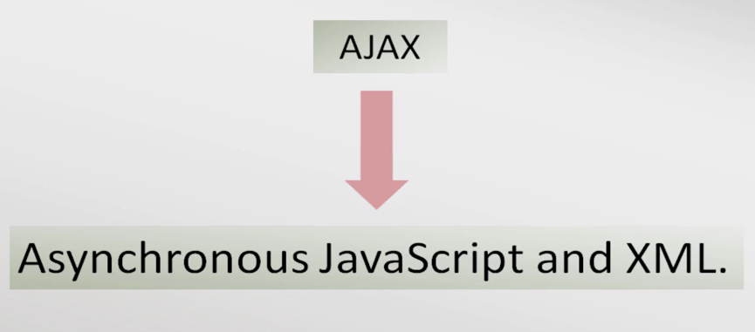

*XML is outdated rather JSON format is used

Facebook uses AJAX method of data loading on its site. All the components of the page are loaded separately, the news feed, ads, chats etc. News feed scrolling adds new feeds at the end. And this occurs by DOM manipulation of creating a template for new feeds. The data for those feeds are fetched from tables

XMLHttpRequest object

XMLHttpRequest is an API in the form of an object whose methods transfer data between a web browser and a web server. The object is provided by the browser's JavaScript environment.



Synchronous vs Asynchronous:

synchronous code is executed in sequence – each statement waits for the previous statement to finish before executing. Asynchronous code doesn't have to wait – your program can continue to run. You do this to keep your site or app responsive, reducing waiting time for the user

Asynchronous code implementation

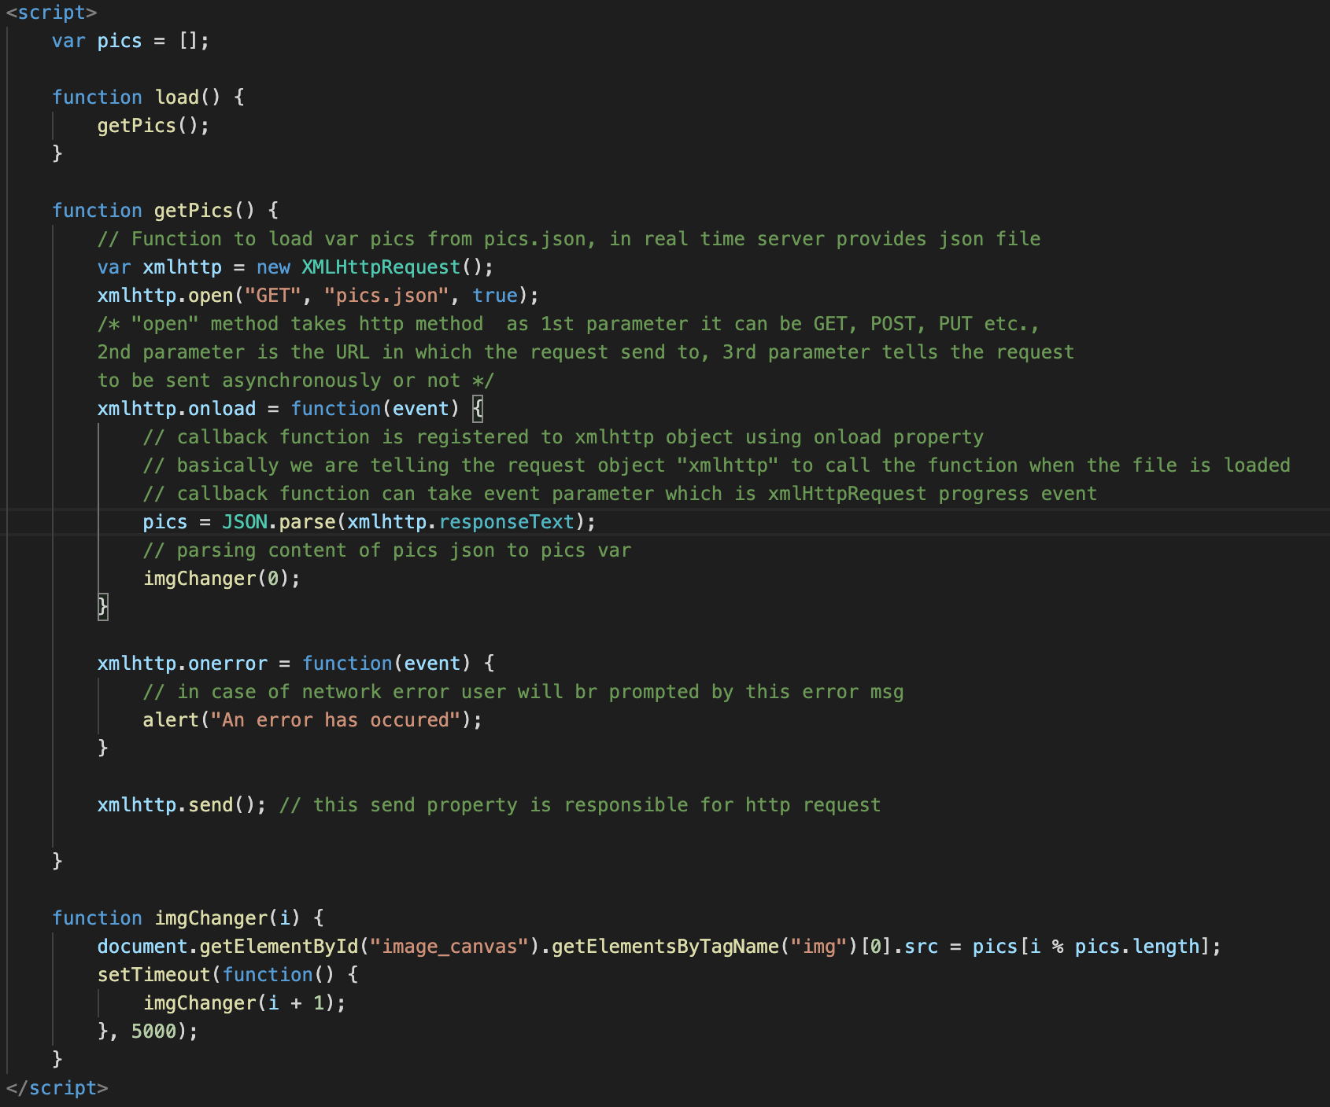

Using var keyword for local variables

If var keyword is not used in local variables such variable is considered as global. This kind of bugs are really hard to find out. So it is better to declare them with var.

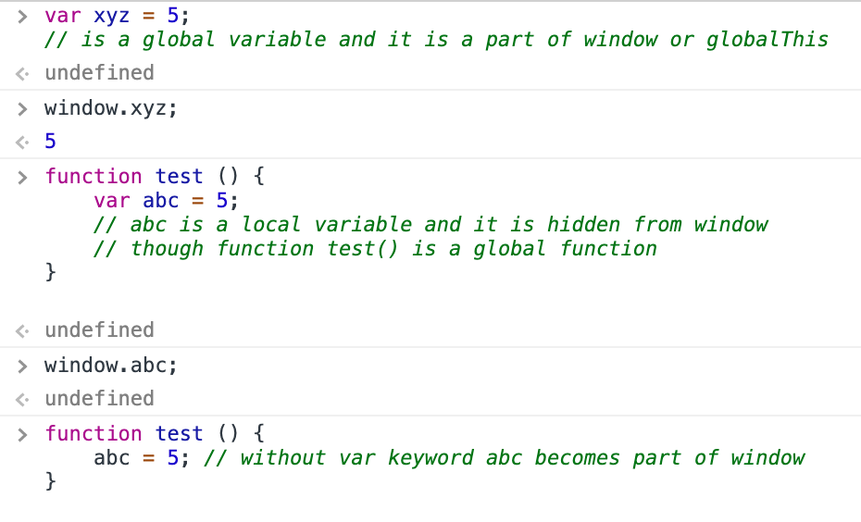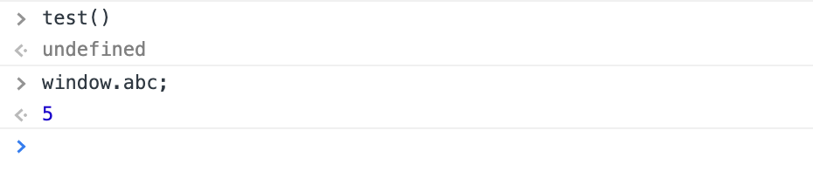

Similarly for constructor function when declaring an object it’s better to use new keyword

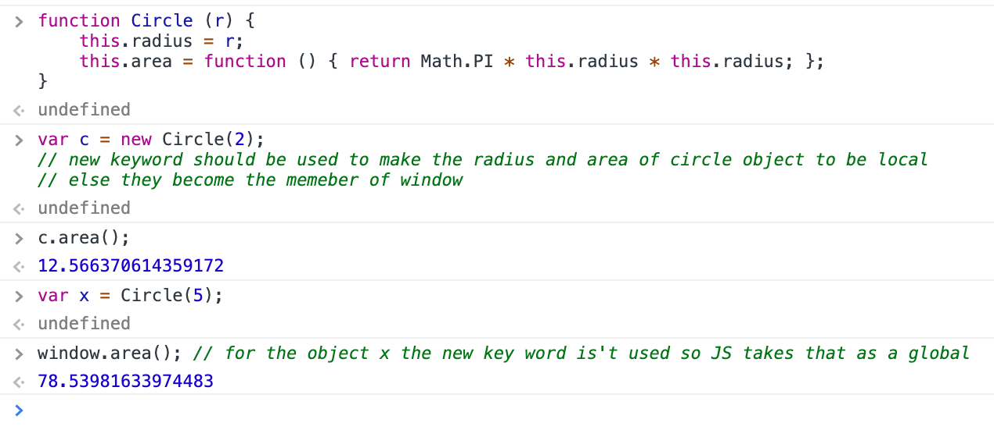

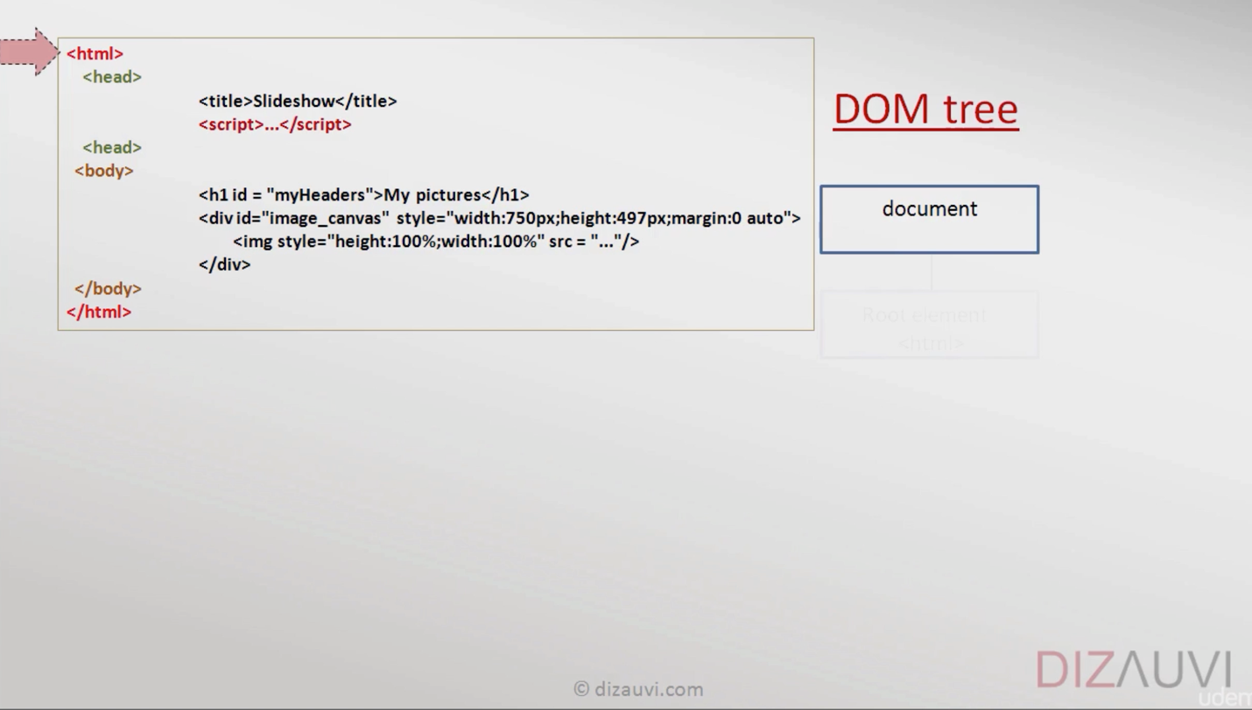*in general prefer not to use global variable since they may overwrite existing variable of same name

Browser working

https://taligarsiel.com

It’s good to put script tag at the end of body element so to give time for DOM to load html elements. In such way the script can manipulate the webpage by accessing DOM contents. This convention suit for both inline and external JS.

DOM tree

“defer” and” async - (html 5)” attributes is available only for external JS. These attributes tell the browser to execute the external JS script after loading html document. i.e., after the DOM parses the html, the JS scripts will be executed. Mostly async is used to call external libraries like jQuery.